Competencies to Advocate for the SC Roles (Section A)  Advocacy is showing the stakeholders that our work aligns with what is important.  1. Advocate for schoolwide policies, protocols and training for response to bullying, harassment and bias incidents centered in safety, belonging and justice (A.11.b) ASCA  2. Advocate for equitable, anti-bias policies and procedures, and provide effective, evidence-based and culturally sustaining interventions to address student needs (A.1.j.)  3. Advocate for accessible, effective tools for students or community to report incidents of bullying, hate or bias (A.11.c) ASCA | Design and Evaluation of SC Programs (Section C)  *Developed in (COSC 661)  1. Career Decision Making Interventions. Helps shape students’ academic and professional trajectories (Zeng, et.al., 2025)  2. Incentive Fund Programs. Supporting education and workplace readiness (Osman, et.al.,2025)  1.Consult to support student achievement and success  2.Collaborate with families, teachers, administrators, other school staff and education stakeholders for student achievement and success (B-SS 6) | July 25, 2025  9:30 p.m.  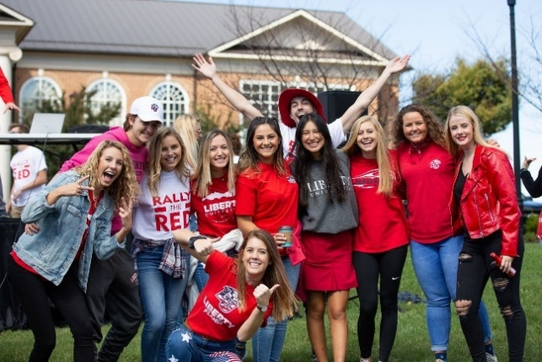  Mission, Vision, Beliefs Statements  Liberty University practices a faith-based counseling program and that program is counseling with purposes. The Mission: of the program is to ensure equity, access and success for all students which will ultimately produce academic achievement, career readiness as well as social and emotional development for long-range results. Vision: To successfully implement school counseling programs that outlines the school’s values and objectives and represents their core beliefs. Basically, to create a clear picture of success for all students. And to improve the counseling curriculum to better meet the needs of students 5 to 15 years away. Beliefs: Every student can learn and be successful and have access to opportunities for higher-education. (ASCA, 2019).  Liberty University  1971 University Blvd.  Lynchburgh, VA 24515  (855) 731-2512  https://www.liberty.edu | Liberty University  School Counseling Brochure  
Use of Developmentally Appropriate Career Counseling Interventions and Assessments (Section E)  1.Use achievement, attendance and/or discipline data to create annual student outcome goals aligned with school improvement plans (B-PE 3)  2.Utilize components of the ASCA National Model to document data-informed, student-focused activities that demonstrate evidence of meeting standards of performance appraisal instruments (B-PE 9)  3.Use student data and results from survey tools to monitor and refine student outcome goals (B-PE 3)  Career Assessment?  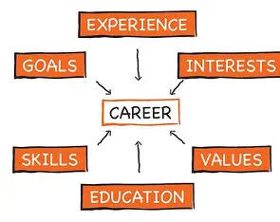 | 
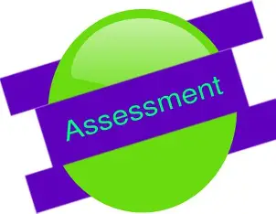
Interventions to Promote Academic Development (Section D)

1.Write measurable format such as the SMART goal format, and include goals aligned with school improvement plans (B-PE-3) ASCA Model

2.Help students understand the importance of postsecondary education and/or training as a pathway to a career ((B-ss 2.e) ASCA Model

3.Act as a change agent to create an environment promoting and supporting student success (B-PF 9.a.) ASCA Model

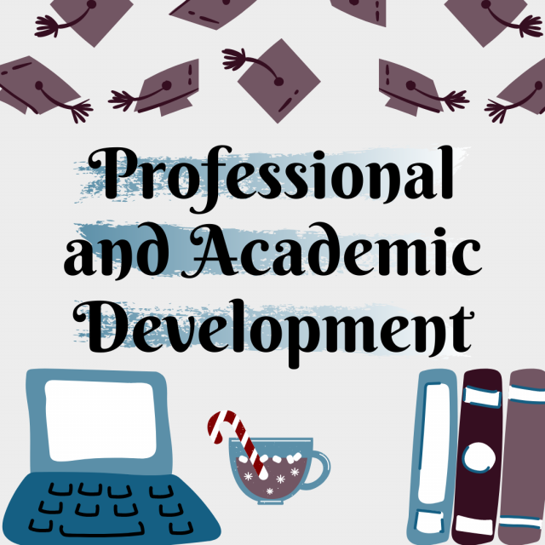

Use of Data to Advocate for Programs and Students (Section J)

*Developed in (COSC 661)

School counselors use data to advocate for student needs and the school counseling program. Data can be used to promote reduction of inappropriate non-school-counseling-related tasks, when then creates more time to address student needs revealed in the data (ASCA 2019). 

Techniques of Social/ Emotional Counseling (Section F)  1.Use counseling theories and techniques in individual, small-grouo, classroom and large group settings to promote social/emotional development (B-PF 1)  2.Use learning theory to support student achievement and success, including students with diverse learning needs (B-BF 1)  3.Advocate responsibly for school board policy and local, state and federal statutory requirements in students’ success (B-BF 8) | Interventions to Promote College and Career Readiness (Section G)  1.Connect students to workplace experiences to deepen understanding and explore career interests (B-SS 3) ASCA Model  2.Use learning theory to support student achievement and success, including students with diverse learning needs (B-PF 1) ASCA Model  3.Act as a systems change agent to create an environment promoting and supporting students’ success (B-PF 9) ASCA Model | Approaches to Increase Promotion and Graduation Rates (Section H)  *Developed in (COSC 661)  Most importantly, it is crucial to establish a student and counselor relationship in order to encourage the student to participate in their desire graduate.  1.Help students understand the importance of postsecondary education and/or training as a pathway to a career (B-22 2) ASCA Model  2.Help students and families navigate postsecondary awareness, exploration, admissions and financial aid process (B-22 g) ASCA Model | 
 | Strategies to Promote Equity in Student Achievement and College Access (Section I)  1.Partner with others to advocate for student achievement and educational equity and opportunities (B-SS 6) ASCA Model  2.Make referrals to appropriate school and community resources (B-SS 4) ASCA Model  3.Model school counseling advocacy competencies to promote school counseling development and student success (B-PF 8) ASCA Model | 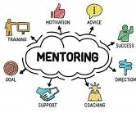 | Strategies for Implementing and Coordinating Peer Intervention Programs (Section K)  1.Mentoship Intervention Program  2.Virtual Peer Support  3.Coolaborative Writing with peers

References

American School Counselor Association (2019). ASCA national model implementation guide: Manage and Assess (2nd ed). Alexandria, VA: Author. ISBN: 9781929289608

Zeng, H., & Ma, C. (2025). Assessing Career Decision-Making Interventions: Effects of Career Courses and Group Counseling on High School Students. The Career Development Quarterly, 73(1), 68-78. https://go.openathens.net/redirector/liberty.edu?url=https://www.proquest.com/scholarly-journals/assessing-career-decision-making-interventions/docview/3180214562/se-2

Osman, N., & Drape, T. (2025). The Role of Incentive Fund Programs in Supporting Education and Workforce Readiness. Journal of Applied Research in the Community College, 32(1), 35-49. https://go.openathens.net/redirector/liberty.edu?url=https://www.proquest.com/scholarly-journals/role-incentive-fund-programs-supporting-education/docview/3190907993/se-2

