Praxis 5205 Score Report

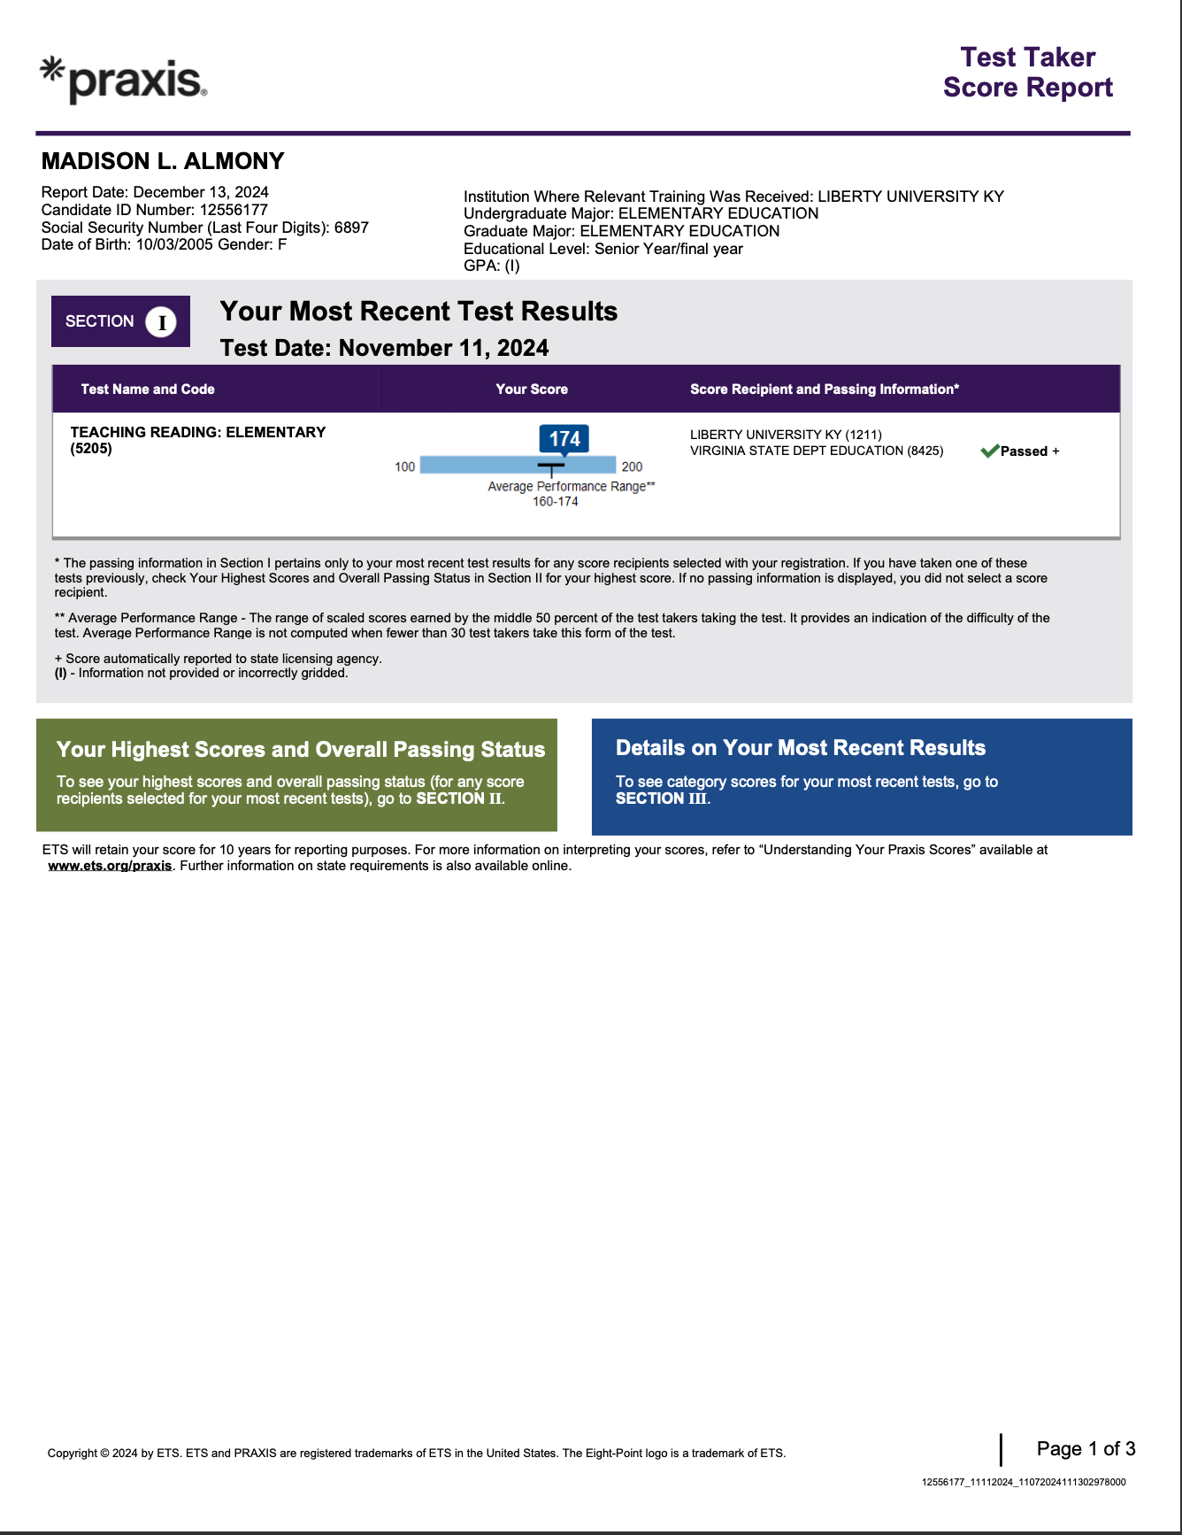
Praxis 5001 Score Report
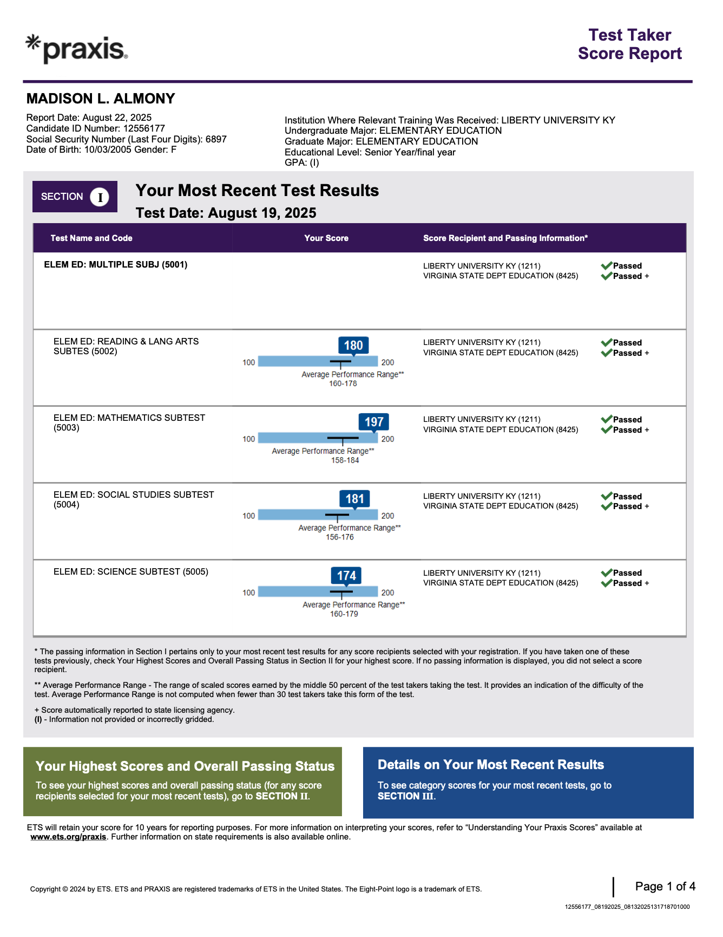

Child Abuse and Neglect Certificate

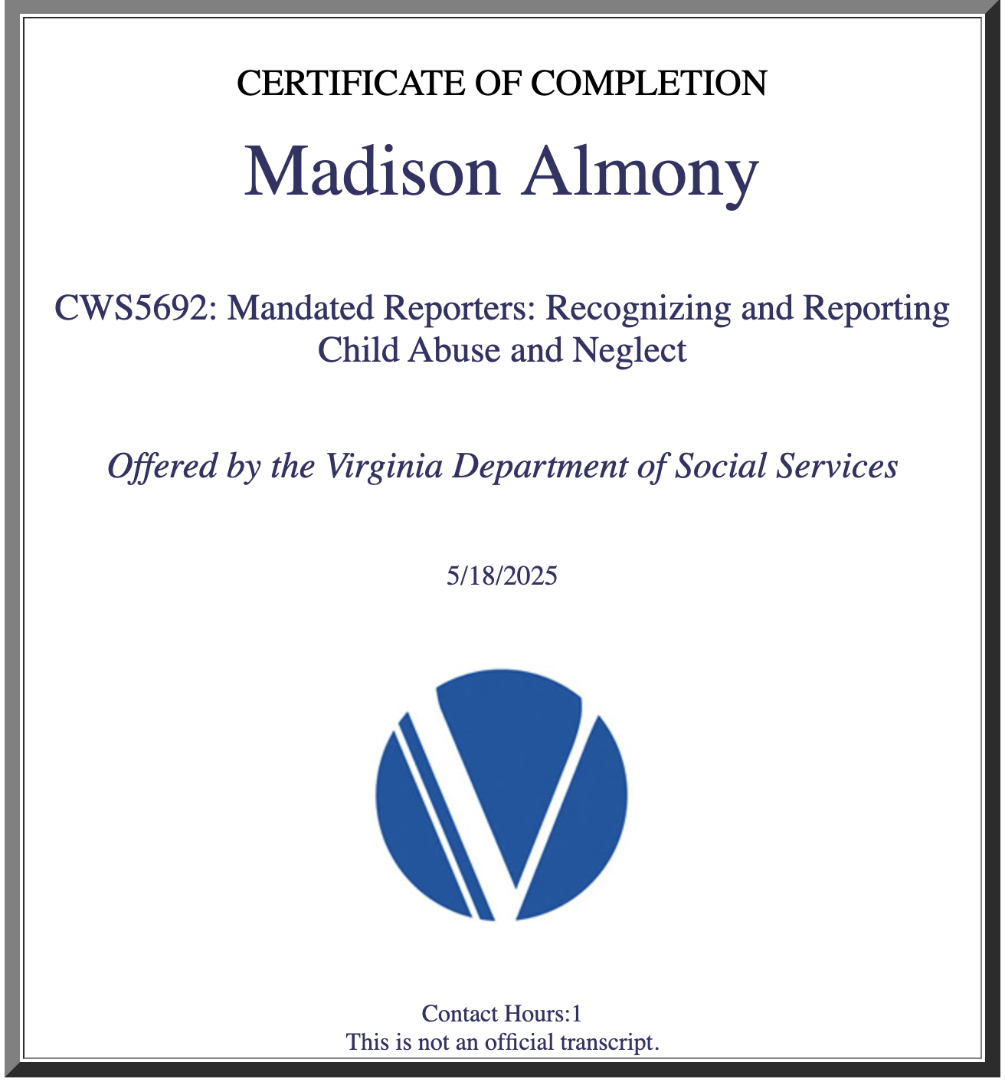

Restraint and Seclusion in Elementary Schools Certificate

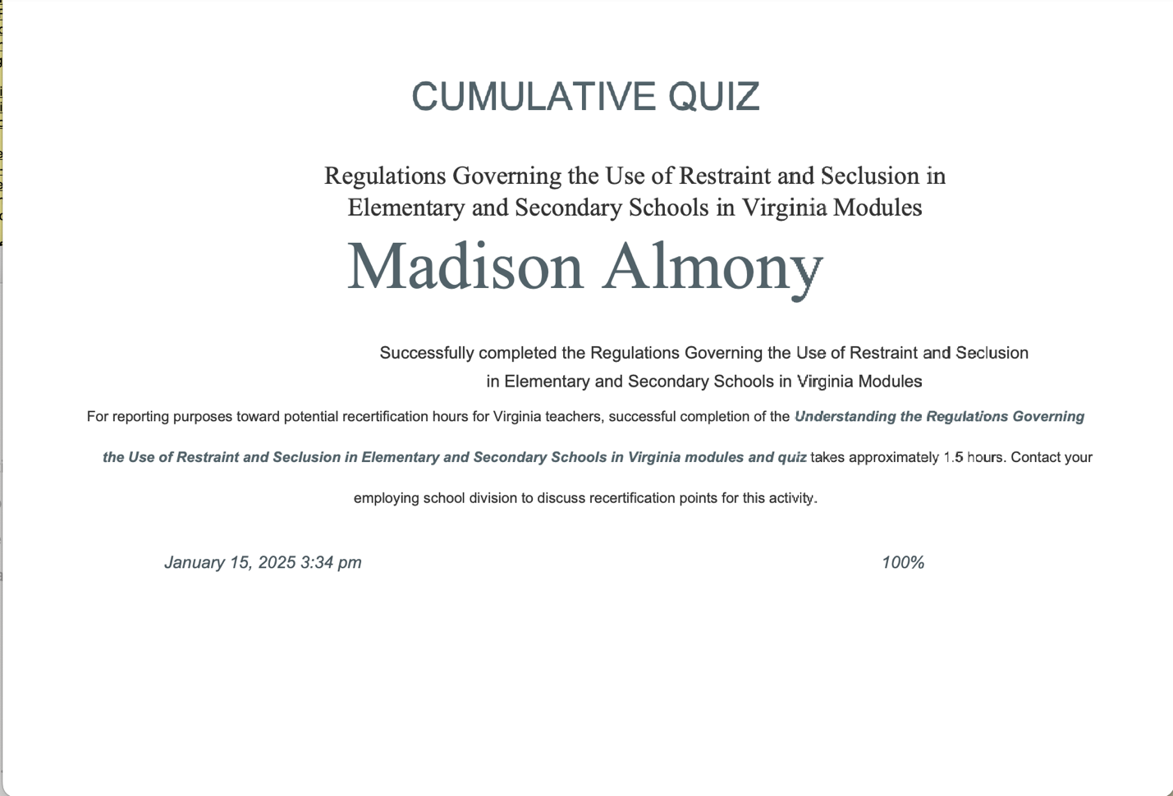

First Aid and CPR Certificate

