Legal Entanglement Project: Part 1 – Preliminary Communication and Advocacy Plan

Samuel Pedersen
School of Education, Liberty University

Author Note
Samuel Pedersen
I have no known conflict of interest to disclose.
Correspondence concerning this article should be addressed to Samuel Pedersen.
Email: stpedersen@liberty.edu

Legal Entanglement Project: Part 1 – Preliminary Communication and Advocacy Plan
Stakeholder Interview #1
Stakeholder(s) Name(s): Jamie Cason
Stakeholder Position or Group: High School Principal
Date of Interview: 5/28/2025
Summary of Interview
Mr. Cason and I spoke about the existing challenges facing our district when it comes to students showing a lack of respect for the school-provided technology that they use during the school day. This past year was Mr. Cason’s first year as a principal, and he shared that this was one issue that he did not anticipate when he began his job. While he is optimistic that student behavior can improve with the right policy in place, he stated that it was unlikely to improve with the current regulation at our school. Mr. Cason shared that he is currently working on a revision of the high school student handbook and there were specific needs for implementing a policy that would discourage students from destroying school equipment. I was in complete agreement, and added that, while I had not directly experienced students harming technology in my classroom, I had spoken with several teachers in our school that had witnessed students disrespecting school technology, even to the point of tearing them apart. He was aware of these issues, which is partially why an update to the handbook was required. He believes that a financial penalty should be put in place with a “3-strike” system that requires families to take on the cost of repairing or replacing damaged school property. He was excited that I am working on this project, and wanted to implement my work into the new handbook upon completion. Jamie mentioned that a new policy will likely be installed sometime in late June, which I was excited to hear.
Follow-Up Communication
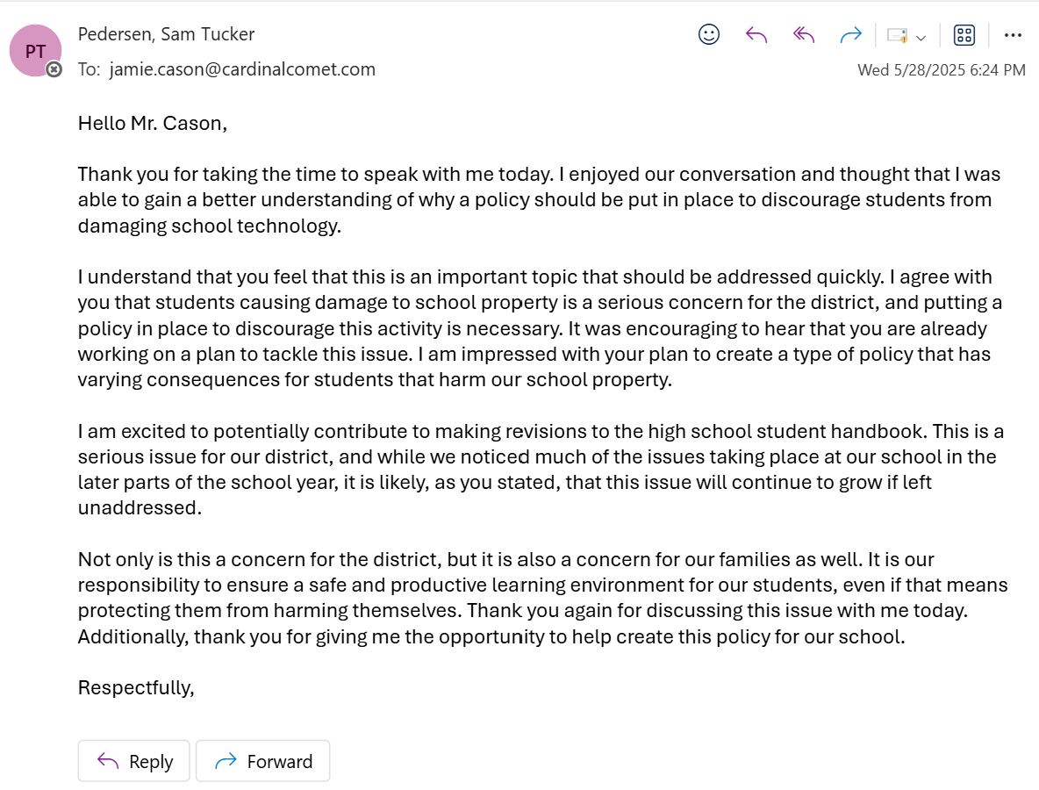

Stakeholder Interview #2
Stakeholder(s) Name(s): Jenny Little
Stakeholder Position or Group: District Technology Director
Date of Interview: 5/28/2025
Summary of Interview
Mrs. Little has worked in my school for a number of years, holding several positions within the district. She is not only an experienced educator, but a mother to students in the elementary school. She was excited to speak with me about the issue of students damaging school technology, and shared some insightful thoughts about what her research on the topic has shown her. When I went to speak with Mrs. Little, she was working on repairing a Chromebook that had already been damaged by a student. She has a passion for seeing change brought to this issue, and was excited that I am working to come up with a solution to this challenge. Jenny let me know that many less tenured teachers have struggled to keep students from damaging school Chromebooks. She has looked into multiple districts’ policies, and believes that while we may have certain policies in place that would discourage the damage to school property, there is nothing in place which directly addresses school technology. She thinks that there are several ways to discourage students from harming school technology gear, but one of the most effective she has found is implementing a financial penalty for discouraging students from damaging technology in the district. Not only is Mrs. Little worried about the damage to the property, she is also concerned that this behavior could harm students. She differentiated between students accidentally breaking technology and students purposefully destroying it. Mrs. Little encouraged me to collaborate with Mr. Cason on this issue, and I promptly told her I was already on top of that. Overall, she shared some important thoughts about why policy is necessary for this issue, and was supportive of my work.
Follow-Up Communication
