Field Experience Summary (FES) School Counseling Program Cumulative Field Experience Log
 | Candidate: Taryn Butcher (Morales) |  |  |  |  |  |  |  |  | LU ID#: L31743429
 | Field Experience Semesters (3): The rows below are for hours earned in the practicum, internship 1 and internship 2 placements during enrollments in COSC 692/COUC 692 and COSC 693 Part 1 and COSC 694 Part 2. The COSC 692/COUC 692 practicum, COSC 693, and COSC 694 internships are supervised by a licensed practitioner with clinical or school counselor supervision credentials and training. Briefly describe activities that support the columns to the right (diversity, exceptionalities, collaboration, etc.) Practicum: A minimum of 100 cumulative hours must be accrued during the semester: At least 40 hours must be “direct” service hours (see below.) Internship 1: A minimum of 300 cumulative hours must be accrued during the semester: At least 120 hours must be “direct” service hours (see below.) Internship 2: A minimum of 300 cumulative hours must be accrued during the semester: At least 120 hours must be “direct” service hours (see below.)
List the Beginning & Ending Date of Practicum & Internship Placements: |  | Course prefix/number | Direct Hours | Indirect Hours | List Practicum and Internship Site(s)  Name, City, and State for placement  AND  List Site Supervisor’s Name for placement: | Population Served  (Grade Levels) | Christian,  Public, Other | Diversity |  |  | Exceptionalities | Collaboration
Practicum |  | 692 | 214 | 197 | Four Corners Elementary  Salem Oregon  Allison Silbernagel | K-5 | Public | Cultural recognition & celebrations |  |  | Tiered levels of support, intervention groups, skill building, collaborative efforts with community partners to access resources | Connection to community resources, parent involvement, teacher and counselor problem solving, PBIS systems, advocacy for outside services
Internship Part 1 |  | 693 | 246 | 249 | Four Corners Elementary  Salem Oregon  Allison Silbernagel | K-5 | Public | Culturally inclusive practices, community building, partnerships with local tribes, celebrations of all cultures |  |  | Student mentorship, extra curricular activites, big brother/sister program, access to reading writing and math excellerations, progress monitoring for chronic absences, incentives for students, MTSS, intervention groups, skill building, collaborative efforts with community partners to access resources | Partnerships with community resources, coordination with MVP program, connections with local donations, community outreach projects, feedback and input from local tribal communities, cultural events
Internship Part 2 |  | 694 | 379 | 189 | Split Placement  Four Corners Elementary School Salem Oregon  &  Houck Middle School  Salem Oregon  Allison Silbernagel | K-5  &  8th | Public | Culural celebration and recognition, community partnerships and wrap around support services, tribal representation |  |  | Progress monitoring and attendance tracking of Native AI/AN students, tribal partnerships for student success, school wide behavior and attendance incentives, MTSS and tiered levels of supports, intervention group implementation, skill building, community resource access | District and community resource partnerships and referrals, coordination and outreach with temporarily houseless youth support programs, cultural celebration events, literacy and math support nights, extra curricular events
TOTAL: |  |  | 839 | 635
 | Practicum ________411_______ (at least 100 hours)  School Site ___X_____ Clinical Site _______  TOTAL DIRECT: _____214_____________ (at least 40 hours)  TOTAL INDIRECT: ______197____________  TOTAL HOURS: ________411__________  TOTAL GROUP SUPERVISION HOURS: ________24.5_________  Practicum students accrue a minimum of 1.5 group supervision hours each week (WebEx with Liberty course professor.) Required: 21 hours or more synchronized group supervision with Liberty course professor.  TOTAL FACE-TO-FACE SITE SUPERVISION HOURS: _____13______  In addition to group supervision hours, practicum students are required to participate in 1 hour of face-to-face supervision with their site supervisor during each week of the semester of practicum. Required: 10 or more face-to-face site supervision hours.  Internship 1 ______495__________ (at least 300 hours)  Elementary ___X_____ Secondary ______  TOTAL DIRECT: ______246____________ (at least 120 hours)  TOTAL INDIRECT: ________249__________  TOTAL HOURS: ________495__________  TOTAL GROUP SUPERVISION HOURS: ______27___________  Internship 1 students accrue a minimum of 1.5 group supervision hours each week (WebEx with Liberty course professor.) Required: 21 hours or more synchronized group supervision with Liberty course professor.  TOTAL FACE-TO-FACE SITE SUPERVISION HOURS: ____15_______  In addition to group supervision hours, Internship 1 students are required to participate in 1 hour of face-to-face supervision with their site supervisor during each week of the semester of internship 1. Required: 14 or more face-to-face site supervision hours. |  |  |  |  |  |  |  | Direct Hours  Leading/Co-leading Small group Counseling/Individual Counseling  Individual Student Planning (career planning, personal planning, scheduling)  Leading/Co-leading Classroom Guidance Lessons  Assessment (when practicum student is directly interacting with the client/student to engage in the assessment.)  Large group activities that support Core School Counseling Curriculum (examples: Red Ribbon week activities whereby you are interacting directly with students on projects, Drug Awareness assembly given to students, other programs such as peer mediation/peer mentoring whereby you train and meet with students to facilitate mediation/mentoring sessions).  Indirect Hours  Maintaining case notes  Consultation/collaboration with stakeholders for the benefit of the client/student who is not present.  Observations of site supervisor implementing classroom guidance lessons, individual counseling, group counseling, etc.  Large group activities whereby you do not interact directly with students/clients, but only coordinate the activities. This includes planning and marketing the activity.  Other professional activities in which counselors engage on a daily basis in the practicum setting.  1 hour per week on-site supervision  1.5 hour per week Liberty Professor Supervision

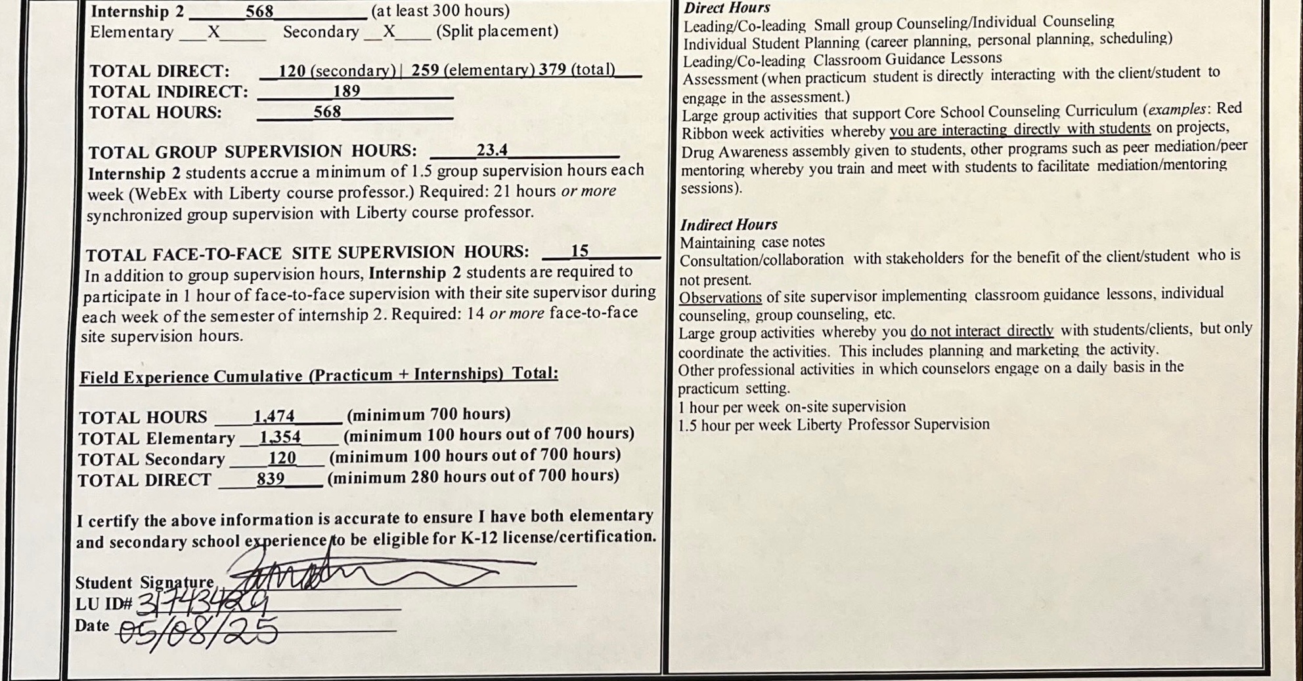

Field Experience Rubric: School Counseling
CAEP | ASCA / CACREP | Setting | Recommended | Required
A1.1d,f | ASCA 3,5,6  CACREP 1,3 | Christian | Two or more field experiences in Christian school setting. The virtual field experience included in COSC 660 may count toward one experience. | Minimum of one field experience in Christian school setting. The virtual field experience included in COSC 660 may count toward one experience.
A1.1d,f | ASCA 3,5,6  CACREP 1,3 | School
A1.1c,d,f | ASCA 3,4  CACREP 3 | Public School | Two or more field experiences in public school setting. | Minimum of one field experience in public school setting.
A1.1c,d,f | ASCA 3,5  CACREP 3,8 | Other settings | Field experiences with K-12 students in more than two different school settings (alternative, private, charter). | Field experiences with K-12 students in one different school settings (alternative, private, charter). The virtual field experience included in COSC 660 may count toward one experience.
A1.1c,d,f | ASCA 3,5  CACREP 3,8 | (alternative,
A1.1c,d,f | ASCA 3,5  CACREP 3,8 | private, charter)
A1.1d,f | ASCA 6  CACREP 3 | Cultural Diversity  (ethnicity, SES, gender, language, urban, rural, etc.) | Field experiences with K-12 students who represent more than two different aspects of cultural diversity (ethnicity, race, SES, gender, language, urban, rural). | Field experiences with K-12 students who represent a minimum of two different aspects of cultural diversity (ethnicity, race, SES, gender, language, urban, rural).
A1.1c,d,f | ASCA 4  CACREP 3,7,8 | Exceptionalities  (learning disability, autism, emotional disturbance, intellectual disability, other health impairment, developmental delay, multiple disabilities, traumatic brain injury, etc.) | Field experiences with K-12 students who represent more than two different categories of exceptionality. | Field experiences with K-12 students who represent two different categories of exceptionality.
A1.1c,d | ASCA 3,5,6  CACREP 3,8 | Grades PreK- 5/6 | Field experiences include more than 100 hours in grades preK-6. | Field experiences include 100 hours in grades preK-6.
A1.1c,d | ASCA 3,5,6  CACREP 3,8 | Grades 6/7-12 | Field experiences include more than 100 hours in grades 7-12 setting. | Field experiences 100 hours in grades 7-12 setting.
A1.1d,f | ASCA 1,6  CACREP 2,3 | Professional organizations/Professional Liability Insurance | Membership and active participation in more than one professional organization for school counselors. Active memberships ASCA is required for practicum and internships. (example memberships include ACA, state counseling/school counseling organizations, AACC, etc.) | Membership and active participation in one professional organization for school counselors. Active memberships in ASCA is required is required for practicum and internships.
A1.1c,d,f | ASCA 1,5  CACREP 3,8 | Total hours for placement | Completed more than 700 hours total, including leading groups. | Completed 700 hours total, including leading groups.
A1.1c,d,f | ASCA 1,5  CACREP 3,8 | Total direct hours for placement | Completed more than 280 direct hours total. | Completed 280 direct hours total.

*Highlighted fields indicate what the candidate has completed in both the required and recommended areas*

