Beliefs  Our belief is that every child is innately important and deserves the right to support if needed. Students should feel safe at school. | Vision  Our vision is for all children to feel safe and supported at school. Our goal is for students to thrive and to prevent bullying. | Weekly Mondays, Wednesdays, and Fridays at 8:00am-8:30am  “Every child deserves to feel nurtured, supported, and safe.” | Nurturing Young Minds  A support group for Elementary-Aged Children  
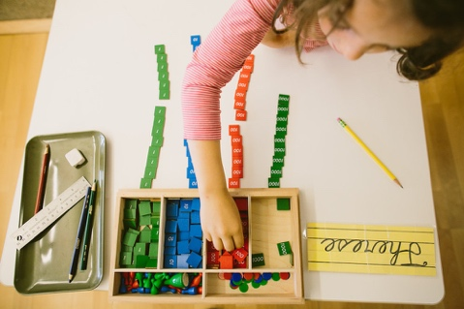   | Mission  Our focus is for students to feel safe, secure, and cared for. Our goal is for students to have equitable long-term success. Our program strives to meet students’ various needs and effect real change in their lives. |  | 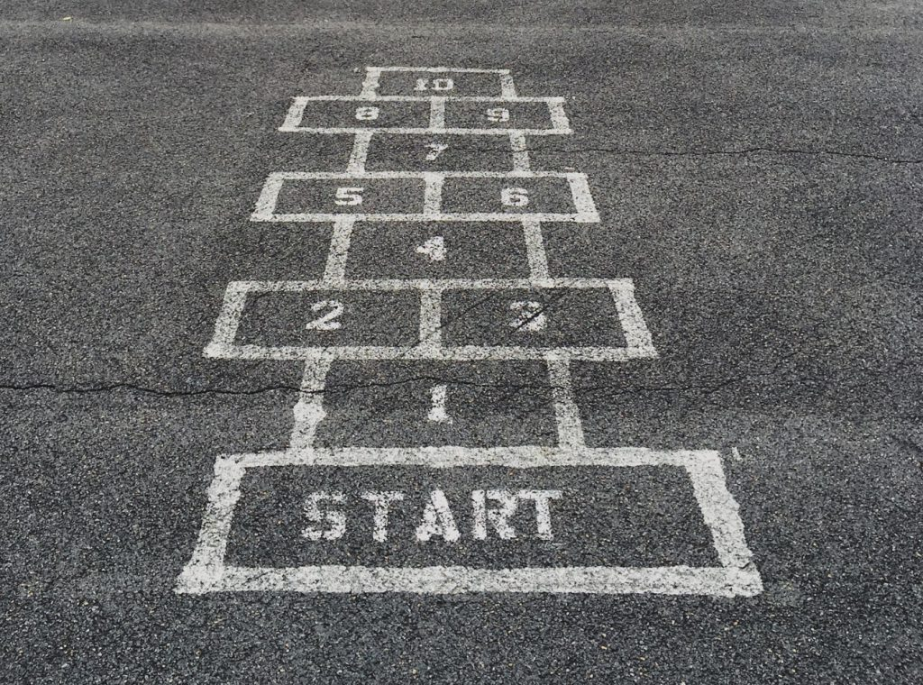
 |  | Morales Elementary  •••  313 Catherine Court West, Monmouth OR 97361  •••  (503)-738-4465  •••  moralesschool@gmail.com  •••  MoralesElementary.org

Advocacy Statement  We advocate for young minds to receive the support systems they need to grow up healthy, safe, and well functioning. Providing a safe space for students to enter in with their problems, be listened to by adults and peers, and be given unconditional love and encouragement. We work to provide time for children to engage in healthy peer realtionships and prevent bullying.  Career Assessment & Counseling Interventions  5th grade students will be able to take the O*NET Interest Profiler Assessment to gauge their career options based on their strengths and interests.  Individualized career counseling will be offered to 5th grade students as they prepare to sign up for classes in middle school, that will prepare them for high school  (ASCA Mindsets & Behaviors B-LS 7, 2021). | Social-Emotional Peer Support and Bullying Prevention Program!  - Safe space for all!  -ASCA Mindset 4  - Postitive peer interactions!  -ASCA Mindset 2  - Anti-bullying information!  -ASCA Behavior B-SS 4  - Group discussions!  -ASCA Behavior B-SS 1    Strategies for Promoting Student Equity  - Emotional support  (ASCA Mindsets & Behaviors B-SMS 1, 2021).  - Academic support  (ASCA Mindsets & Behaviors B-LS 4, 2021).  - Anti-bullying practices  (ASCA Mindsets & Behaviors B-SS 2, 2021).  - One-on-one intervention  (ASCA Mindsets & Behaviors B-LS 2, 2021). | Intervention Groups Offered  Student Mindsets & Behaviors Expectations  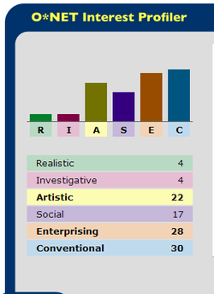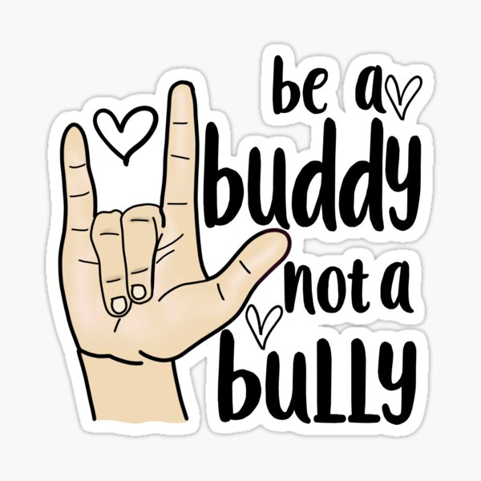  We strive to implement the ASCA Mindsets & Behaviors M2, M4, & M6 in our small group interventions.  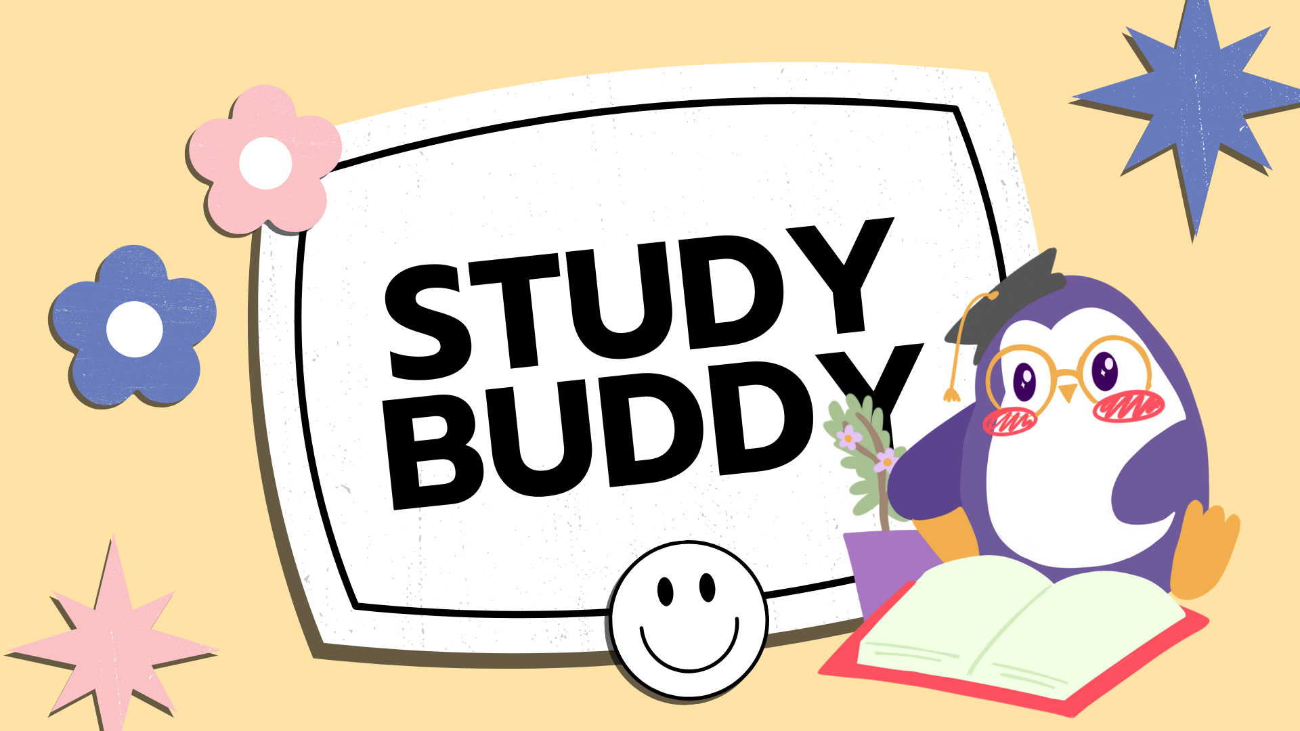 |  | - Be a Buddy not a Bully  -Students will develop a belief in their entire self with a balance of social/emotional and physical well being  (ASCA Mindsets & Behaviors M2, 2021).  - Study Buddy group  -Students will develop a self-confidence in their ability to succeed  (ASCA Mindsets & Behaviors M4, 2021).  - Career Preparation Group  -Students will understand the importance of postsecondary education and the impact it has on lifelong learning as it relates to long-term success  (ASCA Mindsets & Behaviors M6, 2021).
 | Strategies for Transitions  Creating the foundation for students to withstand postsecondary transitions, in their elementary years is crucial. Ensuring that students know how to self-regulate, handle responsibilities, and cope with stress are all strategies to help ease this eventual transition. Preparing children to enter the world as individuals that respect and treat others with kindness is a top priority. | 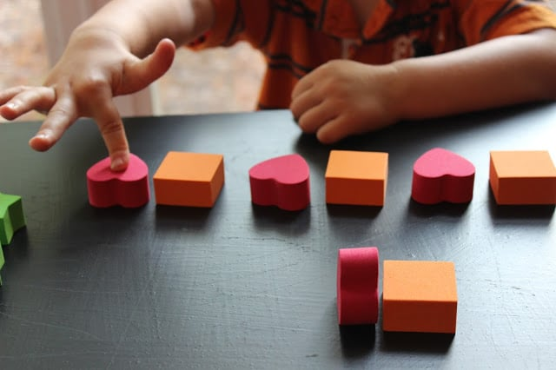 |  | “All children of all ages matter, promoting health and wellness at an early age matters!”
 | A  Method for Data Collection  Take inventory of children’s progress on emotional regulation, academic achievement and physical well-being. Have students self-evaluate mood, satisfaction of intervention group, and any continuing concerns. Utilize data towards improving opportunities for students. |  | Services Provided  - Intervention groups  - Peer-to-peer interactions  - Anti-bullying prevention group practices  - Utilizing the “buddy approach”  - Collaboration with classroom teachers and school policies  References  Tzani-Pepelasi, C., Ioannou, M., Synnott, J., & McDonnell, D. (2019). Peer support at schools: The buddy approach as a prevention and intervention strategy for school bullying. International Journal of Bullying Prevention, 1(2), 111–123. https://doi.org/10.1007/s42380-019-00011-z  ASCA student standards: Mindsets & Behaviors for student success. (2021). https://www.schoolcounselor.org/getmedia/7428a787-a452-4abb-afec-d78ec77870cd/Mindsets-Behaviors.pdf   |   References Continued  Shen, J., Wu, H., Reeves, P., Zheng, Y., Ryan, L., & Anderson, D. (2020). The association between teacher leadership and student achievement: A meta-analysis. Educational Research Review, 31, 100357. https://doi.org/10.1016/j.edurev.2020.100357  Kehoe, M., Bourke-Taylor, H., & Broderick, D. (2017). Developing student social skills using restorative practices: A new framework called H.E.A.R.T. Social Psychology of Education, 21(1), 189–207. https://doi.org/10.1007/s11218-017-9402-1  



