Competencies to Advocate for the SC Roles (Section A)  School counselors are essential to every successful school district. They include support in all areas such as academics, college/career, social/emotional, and any additional support a student needs. School counselors have a variety of activities that they’re responsible for.  -Leading group counseling sessions. School counselors have group counseling sessions to increase positive peer relations and help students gain a sense of belonging.  -Mediate conflicts between students and teachers. School counselors help to resolve conflicts by being an active listener and helping students and teachers find a solution.  -Apply academic achievement strategies. School counselors help students academically by helping them set goals that are attainable for them. School counselors also encourage students to stay after school to get extra academic assistance. | Design and Evaluation of SC Programs (Section C)  Direct services offered to students include group counseling and individual counseling sessions. Group counseling allows students to relate to one another and bond with each other. Individual counseling sessions help students manage stress and develop coping skills. Students might need to meet one on one to discuss academics or their school schedule. Students also might need to meet one on one to discuss personal problems. Indirect services would include referrals, collaboration with parents and teachers, and getting involved in community organizations that benefit the students and school district. | Date  Time  Students have access to the guidance department during the school day. However, it’s suggested that students make  appointments with their counselor so that their counselors schedule is clear, and they can solely focus on  the student. | 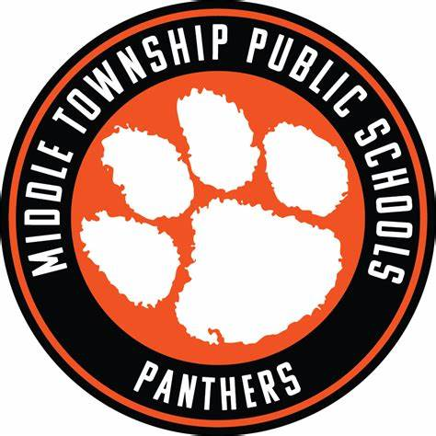
 | Use of Developmentally Appropriate Career Counseling Interventions and Assessments (Section E)  Interventions to Promote Academic Development (Section D)  1. Work collaboratively with school staff to develop a safe, caring and inclusive school culture. Working with others is important because it provides students extra assistance. (ASCA, 2021)  2. Deliver information to students and teachers on best practices to attain mindsets and behaviors. For students to succeed academically, school counselors want to ensure students are mentally strong and are promoting positive behaviors. (ASCA, 2021)  3. Emphasize family/caregiver-community-school relationships in addressing academic needs. It’s important parents and guardians are involved in their child’s academics in case they need assistance at home. The more support the students have the better they can succeed. (ASCA, 2021)  - Learning strategies  Students in 7th and 8th grade can demonstrate learning strategies by reflecting on a reading passage. (Indirect) Students in 7th and 8th grade can also demonstrate learning strategies by listening to their teacher and following instructions. (direct)  - Self-management skills  Students in 7th and 8th grade can demonstrate self-management skills by working independently. (Direct) Students in 7th and 8th grade can also use self-management skills by reflecting on their emotions in a positive way. (Indirect)  - Social skills  Students in 7th and 8th grade can demonstrate social skills by collaborating in small group projects. This can improve their communication and listening skills. (indirect) Students in 7th and 8th grade can also demonstrate social skills by listening to instruction. | 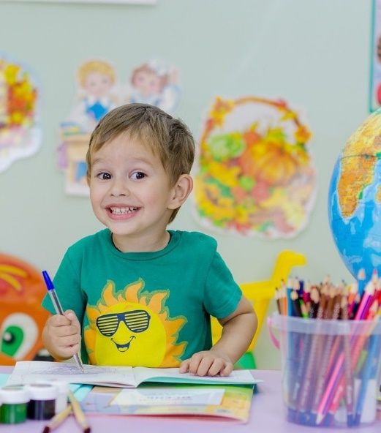  Mission, Vision, Beliefs Statements (Section B)  Provide students with academic and emotional  support to be successful. We want our students to develop academically because we know that this affects other areas of their life. Setting our  students up for success is important to us. The school counselor will help students meet their goals while also supporting them in other  areas of their life. Promoting growth for all of our students without biases to religious, cultural, socioeconomic, gender, sexual orientation and special needs is our priority. All students can achieve greatness when learning in a safe and positive environment. As a result of  the school counseling program, students will feel prepared for the next grade/college. Students will leave high school prepared  for their next step of life weather that be college,  entering a trade or pursuing a job of interest.  Middle Township School  District  •••  300 E Atlantic Ave Cape May  Court House, NJ 08210  •••  1(609) 465-1852  lehmanT@middletwp.k.12.nj.us  https://middletownshippublicschools.org/

Techniques of Social/ Emotional Counseling (Section F)  1. c. Apply the ASCA Ethical Standards for School Counselors and the relevant district policies and procedures. It’s important school counselors follow ASCA to make sure the student is getting the best guidance possible. (Mindsets & Behaviors)  2. e. Consider the student’s chronological age and developmental  Level. Considering the students’ age lets the counselor know what techniques would work best for them. (Mindsets & Behaviors)  3. f. Consider parental/guardian and student rights. This is important because you want to make sure that everyone’s feelings are being considered. (Mindsets & Behaviors) | Interventions to Promote College and Career Readiness (Section G)  - Helping students plan the transition from school to postsecondary education and/or the world of work (ASCA, 2021) Preparing students is important because it sets them up for success.  - Collaborate with administrators, teachers, staff and decision makers to create a postsecondary-readiness and college-going culture. (ASCA, 2021) Collaborating with staff members is important because it suggests ideas you may not have thought of on your own.  3. Practice self-reflection and growth involving traditional career roles and expand equity and access through that growth. (ASCA, 2021) Having students self-reflect on themselves could inspire them to follow a certain career path. Not everyone knows what they want to do after high school, it’s important we try to help students figure out what inspires them. | Approaches to Increase Promotion and Graduation Rates (Section H)  - Provide students with educational learning opportunities like college workshops and trade workshops. Providing options is necessary because not all students want to go to college and not all students want to work in a trade. Showing students, they have options is important.  - Offering programs that prepare students for the next level. Whether they’re preparing for the next grade or preparing for what’s to come after high school, giving them an idea of what’s to come is important so they can be prepared and ready to set goals.  - Educating students is important but sometimes we must educate families as well. Families need to learn what they can do to help their child be successful. Organizing an after-school meeting for parents would be a great idea for them to be up to date on their child’s academic life. | 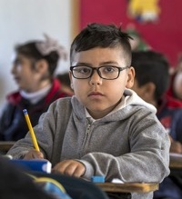
Use of Data to Advocate for Programs and Students (Section J)  An important part of following ASCA guidelines is implementing data. Data is important because it helps school counselors be proficient in collecting, analyzing and interpreting. Data is also important to show others proof. For example, if you’re certain a student needs extra academic help but a staff member disagrees with you. The student could take a test and based on the answers we can determine if the student needs extra help or not. Data and numbers never lie. Data is essential to a school counselor. | Strategies to Promote Equity in Student Achievement and College Access (Section I)  - Using data to identify gaps in achievement, opportunity and attainment. (ASCA, 2021) An example of this would be a school counselor recording a student’s grades to see where they should be placed to be successful.  - Maintaining professional knowledge of the ever-changing and complex world of students’ culture. (ASCA, 2021) An example of this would be staying up to date with ASCA every year.  - Creating an environment that encourages any student or group to feel comfortable to come forward with problems. (ASCA, 2021) School counselors can create positive environments by being proactive, hosting school counseling events and assemblies and letting students know that you are there to help them in all areas of life. | 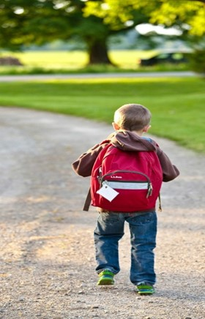 | Strategies for Implementing and Coordinating Peer Intervention Programs (Section K)  - Stay up to date on ASCA to best serve the students. Making sure school counselors have the appropriate training allows them to best serve the students.  - Do your own research. School counselors are responsible for coming up with peer programs, ideas, and strategies that would be most beneficial to their student’s needs.  - Get everyone involved. Students, staff, and parents. Involving the community holds students more accountable when they’re at school and home.

References

Asca ethical standards for school counselors. (2021) (n.d.). https://www.schoolcounselor.org/getmedia/44f30280-ffe8-4b41-9ad8-f15909c3d164/EthicalStandards.pdf

Mindsets & Behaviors for Student Success. (n.d.-b). https://www.schoolcounselor.org/getmedia/7428a787-a452-4abb-afec-d78ec77870cd/Mindsets-Behaviors.pdf

