Beliefs  We here at Spring Mills believe:  - Every student is unique and will be given the equal opportunity to succeed.  - The school counselors will be advocates for everyone.  - Each student will be given the opportunity to be heard and treated with respect. | Vision  “The counseling department here at Spring Mills High is dedicated to reach each and every student socially and emotionally, empower them towards academic success, and guide them into obtaining a fulfilling career, which will help them become productive citizens in the society.” | August 21, 2023  6-8 PM  “Come for a fun night of laughter and learning. We here at Spring Mills High School want you to walk away with a sense of understanding going into the schoolyear.” | The Cardinal Way  Learning to Fly in the Right Direction  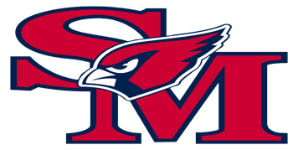
  Learning  to  Paint  Your  Future | Mission  -To provide a comprehensive school counseling program for all  -Lessons designed to promote the holistic development of each student  -To partner with the teachers, parents, guardians, and the community  -To enhance the society through the student’s successful development | 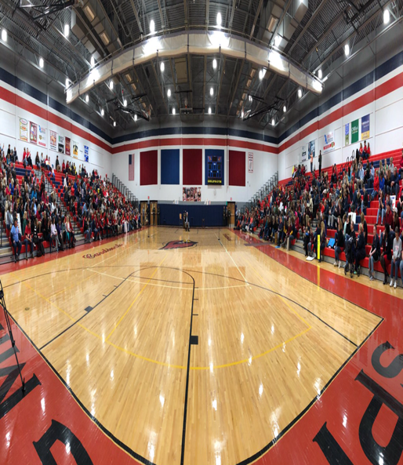 | 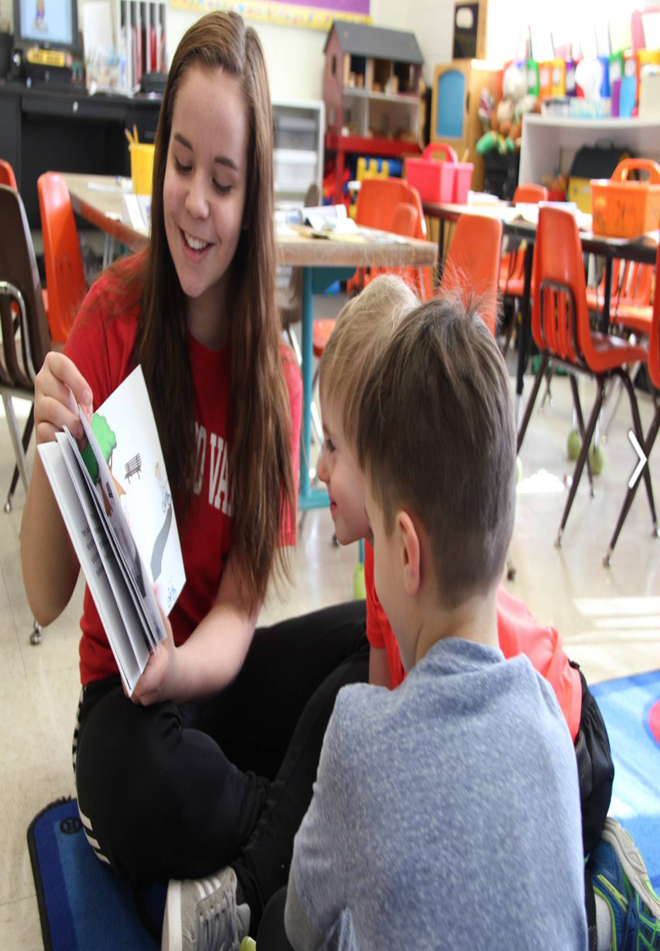
 |  | Spring Mills High School  •••  499 Campus Drive Martinsburg, WV 25404  •••  (304) 274-5141  •••  msalfia@k12.wv.us  •••  https://www.berkeleycountyschools.org/springmillshigh

Advocacy Statement  “The Spring Mills Counseling Department strives to ensure each student is accounted for through a positive school culture, developing teacher led healthy alternative ways to respond to behaviors, and empower students to take charge of their own future.” | Career, Social-Emotional, & Academic & Peer Intervention Program  - OLWEUS (Limber et. al., 2018)  - Jett the Therapy Dog (Policay & Falconier, 2019)  - “Fearless” Resilience Training (Olowokere & Okanlowan, 2018)  - “Cards Helping Cards” Peer Tutoring (Alegre et. al., 2019)  - “Cards for Life”-Career Intervention Group (Lam & Santos, 2018) | Strategies for Promoting equity in student achievement and college success  - EIR Grant Programs  - The Scholarship Resource Coordination Program  - School/County Wide Translators for ESL  - IXL Learning Program  - Homebound “ASSIST” Online Learning Program  - Lunch time clubs (LGBTQ, NBSU, Military club, NHS, Foreign Language club)  - TEAL Classroom (Technology Enhanced Active Learning) |  | 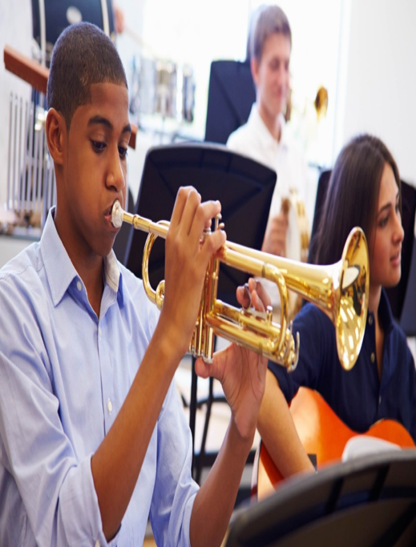
 | Strategies for Facilitating Postsecondary Transition  1. James Rumsey Technical Program-Spring Mills offers an application based technical program, which provides students with skills and opportunities to give them access to learn multiple trades of their choice.  2. Dual Enrollment-The high school provides the opportunity for students with an advanced GPA to begin college classes as an upperclassman. This allows them to get a head start in their career.  3. JROTC-Our Cardinals get an amazing, maturing program to participate in affiliation with the Air Force. The students will gain valuable skills to take into their future, as well as gain them a pathway into the military if they so choose. | 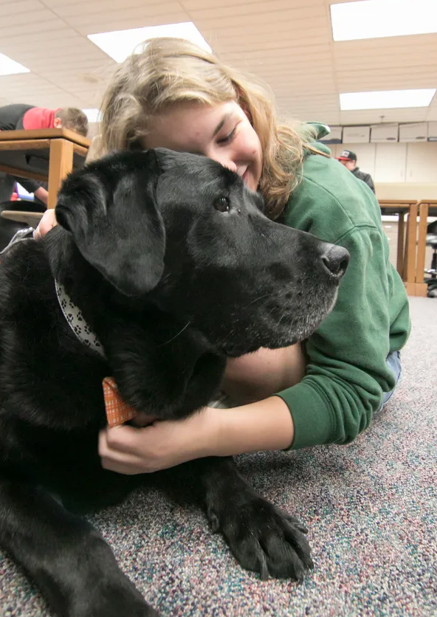 |  | “Spring Mills has been the best 4 years of my life in school. I am grateful for the counselors who have empowered me. With their guidance I am excited to take my next step towards getting a criminal justice degree at WVU”  Lindsay Jenkins  Class of 2023
 | Philosophy of Data Collection  “Collecting and analyzing data help school counselors and their administrators identify achievement gaps, understand educational issues and identify evidence-based interventions that make a difference for all students” (Young & Kaffenberger, 2018, 10)  Methods for Data Collection  With the Spring Mills High School having the opportunity to be a one-to-one Chromebook school, the easiest, most concise way to obtain data throughout the school building has been electronically. Throughout the classroom lessons, lunchtime surveys, individual and group counseling sessions, the school counselors provide opportunities for students to participate in polls, surveys, formal and informal questions, and much more for the purpose of gaining data to always enhance the buildings programs, strategies, and effectiveness.  Sharing Results with Stakeholders  Obtaining the results is very important but getting that information to all the stakeholders is just as important. Within the school building, we provide a monthly department presentation during the faculty meeting. Then, parents and community members are able to take part in our LSIC meetings, which always has a school counselor member who presents updates. Lastly, we love to send out QR codes to the community. This is an easy way for our community to virtually stay up to date with our school.  Here is an example that takes you to our counseling page:  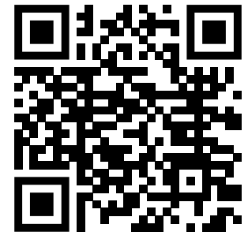 |  | Direct services are the “face to face” services that Spring Mills High provides. It is an opportunity for the counselors to make an impact right in front of the students.  Direct Services Provided  -Individual Counseling  -Group Counseling  -Classroom lessons/Guidance  -Consultation with Outside Stakeholders  -College/Career Fairs  -Postsecondary Site Visits  Indirect services are provided on the behalf of the students as a result of consulting with other stakeholders  Indirect Services Provided  -Referral Consultations  -Family Meetings, Calls, and Emails  -School District Counseling Meetings and Committees  -Working with the Community Business Partners | 

References

Alegre, F., Moliner, L., Maroto, A., Lorenzo-Valentin, G. (2019). Peer Tutoring and Mathematics in Secondary Education: Literature Review, Effect Sizes,

Moderators, and Implications for Practice. Heliyon, 5(9), 1-8. DOI: 10.1016/j.heliyon.2019.e02491

Lam, M., Santos, A. (2018). The Impact of a College Career Interventions Program On Career Decision Self-Efficacy, Career Indecision, and Decision-

Making Difficulties. Journal of Career Assessment, 26(3), 425-444. https://doi.org/10.1177/1069072717714539

Limber, S. P., Olweus, D., Wang, W., Masiello, M., Breivik, K. (2018). Evaluation of the Olweus Bullying Prevention Program: A large scale study of

U.S. students in grades 3–11. Journal of School Psychology, 69(1), 56-72. https://doi.org/10.1016/j.jsp.2018.04.004

Olowokere, A. E., & Okanlawon, F. A. (2018). Improving vulnerable school children’s psychosocial health outcomes through resilience-based training

and peer-support activities: A comparative prospective study. Vulnerable Children and Youth Studies, 13(4), 291–304.
https://doi.org/10.1080/17450128.2018.1499988
Policay, R., Falconier, M. (2019). Therapy Dogs in Couple and Family Therapy: A Therapist’s Perspective. Contemporary Family Therapy, 41(1), 79-91.

https://doi.org/10.1007/s10591-018-9472-z

Young, A., Kaffenberger, C. (2018). Making Data Work 4th Edition. https://mbsdirect.vitalsource.com/reader/books/978-1-929289-56-

1/epubcfi/6/2[%3Bvnd.vst.idref%3Dcvi]!/4/2/4%4050:44

