Legal Entanglement Part 7

Neville Boone
School of Educational Administration, Liberty University
EDAS 747: Advanced Educational Law
Dr. Tammie Brown

Author Note
Neville Boone
I have no known conflict of interest to disclose.
Correspondence concerning this article should be addressed to
Neville Boone
Email: nboone2@liberty.edu

Legal Entanglement Part 1

Narrative Analyzing the Policy in Regards to Moral & Legal Implications
On page 18 of the student code of conduct policy, it states that schools, parents, and the community have a moral obligation and responsibility to help students to maintain and develop positive behaviors. Positive behaviors are expected and displayed during school related activities and the student must maintain self control. Students are required to display behaviors that are tangible for the developing, and growth of the learning environment. Students are expected to respect teachers, administrators and all staff. According to law school has jurisdiction over students on
- School grounds during and after school and in or near school zones.
- On the school grounds as a spectator or when the individual is using school facility
- Of school grounds when associate with school related functions
- Off school grounds when student have conduct contrary to positive behaviors
- Off school ground on bus transportations
- Off campus when student exhibit behaviors that directly affect the safety of staff and other students

Values in School Policies, Programs, and Practices

Part B: Policy, Program, or Practice Amendment/Changes | DiscMoral and Legal Issues/Values in Policy Template  Moral and Legal Issues in School Policy  ussion of suggested amendments or changes relating to Social Justice, Equity, Confidentiality, Acceptance, and/or Respect Between and Among Students & Faculty
  Part A: Policy | Include the actual policy in regards to Moral & Legal Implications
  Cyberbullying | Bullying is a pattern of behavior, which may include written,  verbal, or physical acts, that is so severe,persistent, or pervasive  so as to have the effect substantially interfering with a student's  education,threatening the educational environment, or causing  substantial physical harm or visibly bodily harm. No student  shall sexually, emotionally, verbally, physically, or by any  communication by telephone, mail,broadcast, computer,  computer network, or by any other electronic device or  through the use of electronic communication as defined  in O.C.G.A. 20-2- 751.4 or otherwise harass, threaten,  intimidate, or bully or cyberbully any student, teacher, school  employee, or other person (See Student Code of Conduct  Procedure 4). Any student, in grades 6-12, committing the  offense of bullying for the third time in a school year, shall be  assigned to an alternative school pursuant to O.C.G.A. 20-2-751.4.  Any form of harassment, threats,intimidation, or bullying or  cyberbullying shall be promptly reported to an administrator or  counselor.Teachers may be notified to maintain classroom discipline.
  Bullying | “Bullying” means any willful attempt or threat to inflict injury on another person, accompanied by an apparent present ability to do so; or any intentional display of force such as would give the victim reason to fear or expect immediate bodily harm. This definition has been amended by state law - refer to Board policy JCDAG, Bullying, for complete definition.
  Battery | “Battery” A person commits the offense of battery when he or  she intentionally causes substantial physical harm or visible  bodily harm to another. As used in this Code section, the term  “visible bodily harm” means bodily harm capable of being  perceived by a person other than the victim and may include,  but is not limited to, substantially blackened eyes, substantially  swollen lips or other facial or body parts, or substantial bruises to  body parts. (1) Any person who commits the offense of battery  against a teacher or other school personnel, engaged in the  performance of official duties or while on school property shall,  upon conviction thereof, be punished by imprisonment for not  less than one nor more than five years or a fine of not more than  $10,000.00, or both. O.C.G.A. § 16-5-23.1
School should provide further training and development for staff and students | On page 19 of the policy it speaks on random administrative searches. As a high school business education teacher, every morning my students come to school and they are searched frisked and by the time they are done with the search and seizure students are immensely upset and it is very troubling and challenging trying to teach them during homeroom and first block. I would encourage de-escalating and encouragement tactics after morning search and seizure to better prepare students for learning.
The school should hire outside training consultants to teach on positive behavior skills. | I recommend that the administrators hire outside consultants that can help staff and students learn to connect in a positive and rewarding manner. Consultants can be business leaders who are equipped to form or build positive school cultures.
School should encourage and model positive behaviors. | Building Bridges should follow the PBIS rewards system approach by modeling positive behaviors. The staff should model positive behaviors through attire, speech and interactions with students. Students should model behaviors their teachers are displaying and replicate it throughout the day.

Legal Entanglement 2
Data Analysis

Myers Middle School is an urban area Title 1 middle school located in central Savannah, Georgia. Myers Middle School houses over 552 students grades 6-8 in an area filled with drugs, depravity, and low income. According to Myers (2020), 75% of the parents are considered low income.
According to Myers (2020), the school's equity is very concerning; they are rated a 1 out of 10. The test scores are even more discerning according to Myers (2020); students' overall grade scores for all students on tests are 8 % out of 29% out of all students in surrounding schools. The demographics are as follows, 81% of students are African American, 6% are White, 8% are two or more races, 4% are Hispanic, and 1% are of Asian descent.
Myers's 6-8th grade math score proficiency is 10% compared to the state of Georgia's average score of 43%. Myers English test scores are 11% compared to the state average of 43%, and in science, the school average is 6% while the state average is 39%. The student-teacher ratio is 15:1, while the state average is 16:1. Teachers with three more years of experience are 83% than the state average of 91% (Myers, 2020).
All students at Myers average 29% in suspension rate compared to the states average of 7%. When data is compared by race, Black students average 29% of suspension while the state average is 13% for overall black students suspension rate. White students have a 19% suspension rate compared to the state's overall average of 4%. Two or more races have a 57% suspension rate compared to the state average of 9%. Hispanics have a 42% suspension rate compared to the state average of 5%, and finally, Asian students have a suspension rate of less than one percent while the state average is 4% (Myers, 2020).
These statistics are very alarming. It points to the very fabric of that poor test scores, above average out of school suspensions, and poverty-stricken environments is an instant open door towards aggressive behaviors in the form of bullying, cyberbullying, and battery. These associations create an environment where the trend continues and never ends but open the door towards grief.
As a former teacher at Myers Middle School, bullying, battery, and cyberbullying are some of the major culprits of out-of-school suspensions at Myers. Bullying is a phenomenon that has affected and garnered attention from several educators, administrators and policymakers in the past few years because of the catastrophic effects it has on the victims. Bullying consists of hit, kicking, screaming, pushing, and intimidating (Oliveira, Menezes, Irffi, & Oliveira, 2017).

Policy Analysis
Bullying, cyberbullying, and battery, fall under violation 10 level 2 of the school's policy on page 20. Bullying and cyberbullying have severe consequences and may lead to consequences that would require a student, teacher, administration, and parents conference.
Consequences for level fraction includes, "Detention • Loss of privileges or credit • Restitution • Removal from class • Prohibit attending or participating in extracurricular activities • Behavioral contracts • Counseling • Unsatisfactory (U) conduct grade • On-site intervention • Out-of-school suspension (OSS) at home • Assignment to an alternative educational setting • Suspension of bus transportation • Possible court referral for repeated Level I & II violations" (Student code of conduct, 2020).
Myers Middle School has over 70 teachers; all have bachelor's degrees or higher. 82%of the staff taught over three years. I had the great opportunity to collaborate with Myers Middle School's principal, Mr. Scott, and his administration team, consisting of vice-principal Dr. Dandy and Dean of students Mr. Davis. This meeting's objective was to address the alarming statistics on out-of-school suspensions attributed to bullying, cyberbullying, and battery.
Mr. Scott and his administration and I addressed O.C.G.A. 20-2- 751.4, which addresses bullying, cyberbullying, and battery. Bullying is a consistent behavior of pervasive effects so severe that it affects the learning environment's totality. Bullying can be considered threats, acts of violence that can cause bodily harm, internet threats, and sexual, emotional, verbal behaviors that cause detrimental effects to students. The policy ends with the teacher must maintain control of the classroom environment (SCCPSS.Org, 2020).
While examining the policy, Mr. Scott and I noticed very little information on how prompt teachers should respond when they see cyberbullying, battery, or bullying. Together we recommended three areas of improvement to the policy and for the school.
- Train teachers to pick up on warning signs of bullying, cyberbullying, and battery incidents.
- Drop everything and respond fast, whether writing referrals, contacting the, and stopping incidents immediately.
- Inform students of the repercussions of bullying and remind them of the detrimental effects and consequences bullying can have.
- Inform parents of potential signs and warnings of behavior changes in students.

Focal Group Analysis
The focal group of this presentation is Mr. Scott and his administration team, consisting of Dr. Dandy and Mr. Davis. They will be in charge of informing staff, having staff meetings and training, and organizing parent night outings to enlighten and reach parents of the signs and warnings of bullying, cyberbullying, and battery.
The next focal group will be the teachers and staff; their main focus is to discern behaviors prevalent with victimization, perpetrators, and bystanders' behaviors. This would allow teachers to foster and build positive relationships with all students. Lastly, the parents and all community stakeholders attached to the school and neighboring schools will be addressed and enlightened of the challenges and repercussions of cyberbullying, bullying, and battery causes.
Legal Entanglement Project: Part 3
Myers Middle School operates and functions under the Savannah Chatham County Public School System's principles and guidance, which acts under the responsibility of a safe and orderly environment. Myers Middle School expects every student to:
Model and demonstrate good behaviors on and off school property. Students are expected to notify staff of any questions or concerns in the school, respect all staff members, students, and remain polite. Students are also expected to be role models and consistently remain engaged in lessons (Student code of conduct, 2020).
Myers Middle School defines bullying as a pattern of misconduct or behaviors that can be in writing, physical assault, and threats that may be so severe that it can affect students' abilities to learn. There is a zero-tolerance for such behaviors, including sexual, physical, or emotional threats on phones, social media, emails, or computer networks. All actions can warrant a teacher's discipline referral, a notification by the principal to the parents, parent conference, counseling, intervention, suspension, and long-term suspension or expulsion (Student code of conduct, 2020).
Kara Kowalski versus Berkeley County Schools
In the United States Court of Appeals, Fourth Circuit Court, Kara Kowalski, the appellant versus Berkeley County Schools, Kara Kowalski, a student at Musselman High School in West Virginia, was suspended from school for creating a Myspace account named Students Against Sluts Herpes (S.A.S.H.) for short (Caselaw.findlaw.com, n.d.).
The target of the internet campaign slogan was towards a young lady in the school, and the actions of the school administration led to a five-day suspension. Kara Kowalski argued that the school's actions were blunt with no due process, and it infringed upon her First and Fourteenth Amendment rights of freedom of speech. The district court agreed with the defendant and proceeded by stating that the school district was permissible with their actions for the target student's safety, even if it was off school grounds.
The target student name was Shay N. In December 2005, Kara Kowalski created a group called (S. A. S. H). on the website MySpace and invited 100 people, and at least 24 were from the Musselman High School. Around 3:40 p.m., Ray, a student at Musselman, uploaded a picture of him and a fellow student with their nose turned up, saying that Shay has herpes. Shortly after uploading a picture of her, Kara commented that this picture was the best on social media.
Not too long after Shay's father caught wind of the incident and demanded the images to be taken down, that is when he filed a harassment suit against the discussions group (S.A.S.H.). The school suspended Kara for ten days and banned her from attending any school events for 90 days. Kara Kowalski's case ended with the court agreeing that her actions did not warrant First Amendment rights and the school did not have to tolerate such behaviors (Caselaw.findlaw.com, n.d.). This is a classic example of schools taking the initiative and intervening in harassment. If the school did not intervene, they could have been held liable. According to Cornell (2016), schools are not held liable or required to prevent bullying or harassment, but they must intervene.
L.W. versus Toms River
In the case of L.W. v. Toms River, the issue of the case is whether a school district can be held liable for actions when students are being bullied or harassed by another student based on sexual orientation. The incident began when L.W. was in the fourth grade at South Toms River Elementary School; many students would call him a homo, gay, and a faggot. As L. W. advanced in age and grade level, the harassment only increased. Students would taunt him daily, and they would become physical with him up until the point of molesting him (Edlawcenter.org, n.d.).
The incidents became so severe that L.W. filed a complaint with the Schools administration, which caused them to talk to the students about behaviors and consequences. Some students went to detention, while others were suspended for repeated offenses, several other students went to counseling and interventions. L.W. missed numerous days due to fear of retaliation and humiliation.
The district did have a zero-tolerance policy towards behaviors, but they never reinforced it with letters to parents or modes of communication. The judges heard the case and agreed that the Toms River Regional School Board of Education in New Jersey was held liable, and they awarded L.W. $50,000 in punitive damages (Edlawcenter.org, n.d.).
Gendelman versus Glenbrook North High School
On May 4th, 2003, juniors and seniors from Glenbrook North High School attended their annual Powderpuff game. The incident happened in Cook County Forest Preserve which is off-campus; during this event, members of the junior class were going through a hazing ritual on behalf of the seniors class. All who were in attendance were from Glenbrook High School (Charles, 2003).
The incident was so egregious that it led to 32 students being suspended and five students admitted to the hospital due to hazing. Two students filed a suit by the name of Gentleman and Wessel for a temporary restraining order preventing the students who are suspended from attending graduation. The courts decided against the temporary restraint order because it was not a school-sponsored event, and it did not create any reputable harm. The courts did mention that if the event was held on school grounds, then the school could have been held liable for damages (Charles, 2003).
T.K. versus N.Y.C. Department of Education
T.K. and S.K. have filled a suit on behalf of their daughter L.K. for not providing Free and Appropriate Public Education, better known as (F.A.P.E.). The parents wanted their child to attend a private school for free because their child was being bullied for having a disability is a form of autism spectrum. The parents stated that bullying was a severe deterrence for their disabled child's education. And the school did not take into account or address bullying in her I.E.P.
L. K. is a student who has autism spectrum and used to get hit, pinched, punched, and assaulted during her lunch hour by another student (Weinstein, 2014). The parents wrote letters to the principal about taking proper precautions regarding the incident. The letter led to a parent conference with the principal, which concluded with a promise to investigate the incidents, but the administrator failed to correspond back. During the 2007 through 2008 school year, L.K. went home daily complaining about bullying; this is where the father stated she was too emotional to learn. The courts decided to award the plaintiff the motion of attending private school based on the Burlington test. The courts stated that if states failed to reward (F.A.P.E.), parents could enroll their children into any private school without any cost (Weinstein, 2014).
As a spokesperson for the district, I find each case as a measuring stick as a buffer of how schools should handle and intervene in incidents involving bullying. As in the case of Kara creating a S.A.S.H group, the school had no choice but to intervene on the behalf of the student to prevent liability charges coming from the victims family.
According to ASPA (2019), even though there is no laws specifically pertaining to bullying, under Title IV and Title VI of the Civil Rights Act of 1964, and Title IX of the Education Amendments of 1972, schools are to address any behaviors that are so severe to the point that it creates a hostile environment, and impede on students ability to academical excel. If these behaviors are not addressed schools can be held liable for damages.
Legal Entanglement 4 Literature Review
Bullying in schools
Bullying has become such a significant phenomenon it has caught the attention of many schools and officials across the country. This effect has led to nationwide efforts to reduce and eradicate bullying in schools. Two events that caught the eye of many Americans were the Columbine High School shooting which depicted a victim of bullying as the perpetrator of a mass shooting, and the Davis v. Monroe Board of Education case (Cornell, 2016).
In the Davis v. Monroe Board of Education case, the courts decided to rule in favor of the plaintiff and agreed that schools could be held accountable for not intervening in peer-to-peer sexual harassment. Bullying is an aggressive form of verbal and physical aggression with the intent to inflict harm (Cornell, 2016).
Bullying can be a broad term that can overlap or capitulate behaviors such as criminal, sexual, extortion to lesser forms of aggression which includes teasing, horseplaying, and joking. Other forms are an imbalance of powers that can be in size, strength, verbal abuse with a perpetrator having a cognitive and self-confidence advantage.
Harassment and bullying distinguishment according to the law
According to Title VI no one shall be treated differently based on the color of their skin, national origin, or race. Title IX states that no one should be treated differently based on their sexual orientation. In the case of Davis versus Monroe County Board of Education, the Supreme Court ruled in favor of the plaintiff that the school can be held liable for damages in peer-to-peer harassment. This case was a door opener for future cases requiring schools to become more responsible for students' actions under their care (Cornell, 2016).
The courts create four essentials for schools to follow to prevent or be held liable.
- Schools are held liable if they notice harassment and do not intervene.
- The nature of the bullying has to be so severe and imbalanced that it creates an inability for the victim to learn and grow.
- The school must either know or have seen the harassment; the school cannot be held accountable for harassment if they do not know.
- The school is displaying indifference by not intervening, schools cannot always prevent or cease bullying, but they must interfere (Cornell, 2016).
The Effects of Bullying
The effects of bullying can have long-term effects that are associated with victimization and bullying. According to longitude research, victims of bullying have long-term psychological trauma and have at least 1/3 chance of being exposed to violent acts of aggression or criminal behaviors due to bottled-up emotions. Research has shown that when students are bullied, they have social, emotional, and psychological disorders such as depression.
Research has also shown that 79% of bullied students attempt, commit, or have thoughts of suicide, and 61% have PTSD and severe depressive disorders. Students who are victims of bullying have lower grades and lower engagement connectivity amongst peers. Victims of bullying have difficulty making new friends and have social-emotional function deficiencies (Fullchange & Furlong, 2016).
Stereotypes associated with being bullied
The United States has a systemic stratification and perception and association regarding race, ethnicity, education, and bullying. Stereotypes are defined as judging someone based on their membership, social group setting, or associations. Students learn about race and categories at an early age through actions that influence these preconceived established stereotypes through behaviors, academic skills, and motivating forces for academia (Williams & Peguero, 2013).
In the school house, students who are Black, Latino, or a Minority are associated with low socioeconomic status and have a disadvantage regarding funds for academic excellence. Teachers and students have a preconceived mindset that Black people and Latinos are poor and have limited abilities to succeed. Blacks and Latinos have also been stereotyped as naturally and physically superior and are pressured to enter sports.
If minorities do not comply with the stereotypical innuendos, they become verbally harassed, ostracized, and isolated by their peers. Research has suggested that stereotypes and victimization will only increase in high school due to learned behaviors from society and early upbringing. Also, the preconceived socioeconomic status will increase for Black and Latino with higher tests due to them not fitting the bill of their ethnic, social-economic stereotypical persona (Williams & Peguero, 2013).
The negative parallels associated with bullying
Acts associated with bullying are a widespread phenomenon that has affected over 53% of youth in 6 out of 7 continents worldwide. Youth who have experienced acts of bullying can exhibit negative effects, including fear, doubt, humiliation, sadness, rejection, hopelessness, and helplessness. As time progresses, the adverse effects of bullying can cause side effects such as poor health, suicidal ideation, anxiety, alcoholism, psychological distress, decreased cognitive skills, and overall dwindling well-being (Hall, 2017).
When victims are compared to non bullied individuals, they exhibit low self-worth, lack of self-confidence, lack of self-efficacy, a higher tendency for aggression, and a lower tendency for learning. Victims tend to have family structure dynamics issues. The victims tend to have less hope, and school has moderate to no connections in relation to peer support and life satisfaction. Victims of bullying have higher absenteeism and lower education.
Youth who bully tend to have a harsh social-economic environment with limited resources, and they often have no self-control or lack of empathy. Bullies voluntarily skip school or even drop out. Perpetrators have similar psychological issues as victims, including suicidal thoughts, depression, low self-esteem, and criminal and violent behaviors (Hall, 2017).
Freedom of speech is free, but it should not be used as a weapon
In the case of Saxe v. State College Area School District, the court ruled in favor of the school policy by concluding that there is no freedom of speech protection for language that is considered vulgar, indecent, and offensive to the school environment. Around August 1999 State College Area School District provided a new statute that was formed to hinder and sway destructive verbal behaviors (Alito & Rendell, 2001).
The statute was in the form of an anti-harassment policy intended to make students on campus fuel safe, inviting, and comfortable in the learning environment, free from distractions or offensive language. Under the policy, harassment is anything unwelcome, including language, vulgarity, jokes, solicitation, bullying, sexual advances, to name a few (Alito & Rendell, 2001).
The anti-harassment policy furthers by giving a vivid view or description of harassment in the form of racial, sexual, and disability harassment. David Saxe is the plaintiff representing on behalf of his two sons who attend SCASD. He stated that the new policy would infringe on his children's First Amendment rights. Mr. Saxe furthers by expressing his concerns regarding a teacher at the school is who is homosexual, and is a source of concern for him and his children because they are Christians. As a Christian, Davis Saxe believes that the lifestyle of the teacher was sinful and harmful for the learning environment (Alito & Rendell, 2001).
The plaintiff believes that it is his moral obligation to stand and speak on behalf of his religion. The court's motion to dismiss the plaintiff's case because it is considered unconstitutional. The court also rejected the case because the policy which talks about hostile work or school environments is similar to Title VII, Title IX, of the Pennsylvania Human Relation Act (Alito & Rendell, 2001).
The courts furthered by stating that harassment is not considered a form of freedom of speech. The plaintiff brought up the Tinker versus Des Moines Independent Community School District case in which the district tried to silence students for wearing armbands. According to the courts, the Tinker case was not relevant nor can be compared because they operated in the silent and passive strike that was not destructive to the environment in the Tinker case. This case concludes schools can be held liable for acts of bullying and harassment. That is why their policies are written for the protection of the populace (Alito & Rendell, 2001).
In the case regarding Zamecnik v. Indian Prairie School District 204, a few students from Neuqua Valley High School sued the school district for infringement of their First Amendment rights, of freedom of speech. The students were religious, and they took offense to the lifestyle of same-sex relationships. The two students were upset that a Gay Lesbian and Straight Network group would come onto their school campus and wear t-shirts that brought awareness against harassment towards same-sex relationships (Caselaw, n.d.).
The event was called the Day of Silence, and many of the school's students and staff would wear shirts such as "be who you are" to discourage harassment against homosexuals. The plaintiffs who are now graduated attended school the next day with a shirt saying, "be happy, not gay." The plaintiffs stated shirts were not intended to cause a Ruckus or harm to anyone but to stand for their beliefs. The plaintiffs brought up the case Chaplinsky v. New Hampshire, where the courts ruled in favor of the defendants based on the shirts "homosexuals go to hell." The plaintiffs explained that they could not wear those words on their shirts because they can provoke violent and aggressive behaviors towards them (Caselaw, n.d.).
The plaintiff stated that their school, which provides a platform for one advocacy, cannot stifle the opinions of the opposing party. The courts concluded the t-shirt was not causing a disruption to the learning environment, and the schools should use their platform to open up their floors for debate or discussion on different views. In this case, schools were not held liable, but it was encouraged to educate and create an atmosphere where debate is encouraged.
In the case of Emmett vs. Kent School District number for 415. Nick Emmett, a high school senior attending Kent lake High School, was the co-captain of the boy's basketball team; with no discipline issues, and a high GPA, he decided to create a posthumous post on the web called The Unofficial Kent Lake high homepage.
The plaintiff did notify viewers that this page had no affiliation with the school and only for humorous purposes. The page was created on February 13, 2000 and was written as a monk obituary of the death of students and staff at the high school. On February 16 2000, the news caught wind of the website and described it as a hit list on behalf of Nick Emmett. Nick Emmett took the page down and was ordered to be present the next day in the principal's office.
The principal acted out of haste by expelling Nick Emmett, but they later modified the sentence to five days. With the five days suspension, students cannot engage in any school-related activities, which includes basketball.
Chief Judge Coughenour stated that yes, the First Amendment awarded citizens the right to express their opinion, but it cannot disrupt the school's operations. The school abruptly handled the situation and was ordered that school suspension not count or be affected against the plaintiff. The judge stated no evidence of violence or potential harm targeting the school, staff, and students (Law.Justia.com, n.d.).
In the case, Tinker versus Des Moines Independent Community School District, a group of students with concerns regarding the Vietnam War staged a meeting at Christopher Eckhardt's house. The goal of the meeting was to demonstrate in the act of solidarity with a peaceful protest against the Vietnam War with an armband (Law.Justia.com, n.d.).
When the school's principals caught wind of the protest, they quickly adopted a policy to prevent students from wearing armbands. Even though this case does not have anything to do with bullying, it puts the school in an odd scenario where they seem to act out of haste as a bully by adopting policies preventing peaceful protest (Law.Justia.com, n.d.).
The court case wound up in favor of the Tinker family, which played a part in the First Amendment and the Fourteenth Amendment rights of freedom of speech and due process clause. All past cases used this case as a reference for or against bullying. The schools are held liable if they do not intervene, but they must use caution and not act out of haste.
Legal Entanglement Part 5
Data Analysis

Myers Middle School is an urban area Title 1 middle school located in central Savannah, Georgia. Myers Middle School houses over 552 students grades 6-8 in an area filled with drugs, depravity, and low income. According to Myers (2020), 75% of the parents are considered low income.
According to Myers (2020), the school's equity is very concerning; they are rated a 1 out of 10. The test scores are even more discerning according to Myers (2020); students' overall grade scores for all students on tests are 8 % out of 29% out of all students in surrounding schools. The demographics are as follows, 81% of students are African American, 6% are White, 8% are two or more races, 4% are Hispanic, and 1% are of Asian descent.
Myers's 6-8th grade math score proficiency is 10% compared to the state of Georgia's average score of 43%. Myers English test scores are 11% compared to the state average of 43%, and in science, the school average is 6% while the state average is 39%. The student-teacher ratio is 15:1, while the state average is 16:1. Teachers with three more years of experience are 83% than the state average of 91% (Myers, 2020).
All students at Myers average 29% in suspension rate compared to the states average of 7%. When data is compared by race, Black students average 29% of suspension while the state average is 13% for overall black students suspension rate. White students have a 19% suspension rate compared to the state's overall average of 4%. Two or more races have a 57% suspension rate compared to the state average of 9%. Hispanics have a 42% suspension rate compared to the state average of 5%, and finally, Asian students have a suspension rate of less than one percent while the state average is 4% (Myers, 2020).
These statistics are very alarming. It points to the very fabric of that poor test scores, above average out of school suspensions, and poverty-stricken environments is an instant open door towards aggressive behaviors in the form of bullying, cyberbullying, and battery. These associations create an environment where the trend continues and never ends but open the door towards grief.
As a former teacher at Myers Middle School, bullying, battery, and cyberbullying are some of the major culprits of out-of-school suspensions at Myers. Bullying is a phenomenon that has affected and garnered attention from several educators, administrators and policymakers in the past few years because of the catastrophic effects it has on the victims. Bullying consists of hit, kicking, screaming, pushing, and intimidating (Oliveira, Menezes, Irffi, & Oliveira, 2017).

Policy Analysis
Bullying, cyberbullying, and battery, fall under violation 10 level 2 of the school's policy on page 20. Bullying and cyberbullying have severe consequences and may lead to consequences that would require a student, teacher, administration, and parents conference.
Consequences for level fraction includes, "Detention • Loss of privileges or credit • Restitution • Removal from class • Prohibit attending or participating in extracurricular activities • Behavioral contracts • Counseling • Unsatisfactory (U) conduct grade • On-site intervention • Out-of-school suspension (OSS) at home • Assignment to an alternative educational setting • Suspension of bus transportation • Possible court referral for repeated Level I & II violations" (Student code of conduct, 2020).

Bullying has become such a significant phenomenon it has caught the attention of many schools and officials across the country. This effect has led to nationwide efforts to reduce and eradicate bullying in schools. Two events that caught the eye of many Americans were the Columbine High School shooting which depicted a victim of bullying as the perpetrator of a mass shooting, and the Davis v. Monroe Board of Education case (Cornell, 2016).
In the Davis v. Monroe Board of Education case, the courts decided to rule in favor of the plaintiff and agreed that schools could be held accountable for not intervening in peer-to-peer sexual harassment. Bullying is an aggressive form of verbal and physical aggression with the intent to inflict harm (Cornell, 2016).
Bullying can be a broad term that can overlap or capitulate behaviors such as criminal, sexual, extortion to lesser forms of aggression which includes teasing, horseplaying, and joking. Other forms are an imbalance of powers that can be in size, strength, verbal abuse with a perpetrator having a cognitive and self-confidence advantage.
Savannah Chatham County Public School System defines cyberbullying as
“ any willful attempt or threat to inflict injury on another person, accompanied by an apparent present ability to do so; or any intentional display of force such as would give the victim reason to fear or expect immediate bodily harm. This definition has been amended by state law - refer to Board policy JCDAG, bullying, for complete definition (Student code of conduct, 2020).
SCCPSS defines bullying as any willful attempt or threat to inflict injury on another person, accompanied by an apparent present ability to do so; or any intentional display of force such as would give the victim reason to fear or expect immediate bodily harm. This definition has been amended by state law - refer to Board policy JCDAG, Bullying, for complete definition (Student code of conduct, 2020).
Savannah Chatham County Public School System defines battery as any person who commits the offense of battery when he or she intentionally causes substantial physical harm or visible bodily harm to another. As used in this Code section, the term “visible bodily harm” means bodily harm capable of being perceived by a person other than the victim and may include, but is not limited to, substantially blackened eyes, substantially swollen lips or other facial or body parts, or substantial bruises to body parts. (1) Any person who commits the offense of battery against a teacher or other school personnel, engaged in the performance of official duties or while on school property shall, upon conviction thereof, be punished by imprisonment for not less than one nor more than five years or a fine of not more than $10,000.00, or both. O.C.G.A. § 16-5-23.1 (Student code of conduct, 2020).
In the United States Court of Appeals, Fourth Circuit Court, Kara Kowalski, the appellant versus Berkeley County Schools, Kara Kowalski, a student at Musselman High School in West Virginia, was suspended from school for creating a Myspace account named Students Against Sluts Herpes (S.A.S.H.) for short (Caselaw.findlaw.com, n.d.).
The target of the internet campaign slogan was towards a young lady in the school, and the actions of the school administration led to a five-day suspension. Kara Kowalski argued that the school's actions were blunt with no due process, and it infringed upon her First and Fourteenth Amendment rights of freedom of speech. The district court agreed with the defendant and proceeded by stating that the school district was permissible with their actions for the target student's safety, even if it was off school grounds.
The target student name was Shay N. In December 2005, Kara Kowalski created a group called (S. A. S. H). on the website MySpace and invited 100 people, and at least 24 were from the Musselman High School. Around 3:40 p.m., Ray, a student at Musselman, uploaded a picture of him and a fellow student with their nose turned up, saying that Shay has herpes. Shortly after uploading a picture of her, Kara commented that this picture was the best on social media.
Not too long after Shay's father caught wind of the incident and demanded the images to be taken down, that is when he filed a harassment suit against the discussions group (S.A.S.H.). The school suspended Kara for ten days and banned her from attending any school events for 90 days. Kara Kowalski's case ended with the court agreeing that her actions did not warrant First Amendment rights and the school did not have to tolerate such behaviors (Caselaw.findlaw.com, n.d.). This is a classic example of schools taking the initiative and intervening in harassment. If the school did not intervene, they could have been held liable. According to Cornell (2016), schools are not held liable or required to prevent bullying or harassment, but they must intervene.
T.K. v. N.Y.C. Department of Education
T.K. and S.K. have filled a suit on behalf of their daughter L.K. for not providing Free and Appropriate Public Education, better known as (F.A.P.E.). The parents wanted their child to attend a private school for free because their child was being bullied for having a disability is a form of autism spectrum. The parents stated that bullying was a severe deterrence for their disabled child's education. And the school did not take into account or address bullying in her I.E.P.
L. K. is a student who has autism spectrum and used to get hit, pinched, punched, and assaulted during her lunch hour by another student (Weinstein, 2014). The parents wrote letters to the principal about taking proper precautions regarding the incident. The letter led to a parent conference with the principal, which concluded with a promise to investigate the incidents, but the administrator failed to correspond back.
During the 2007 through 2008 school year, L.K. went home daily complaining about bullying; this is where the father stated she was too emotional to learn. The courts decided to award the plaintiff the motion of attending private school based on the Burlington test. The courts stated that if states failed to reward (F.A.P.E.), parents could enroll their children into any private school without any cost (Weinstein, 2014).
As a spokesperson for the district, I find each case as a measuring stick as a buffer of how schools should handle and intervene in incidents involving bullying. As in the case of Kara creating a S.A.S.H group, the school had no choice but to intervene on the behalf of the student to prevent liability charges coming from the victims family.
According to ASPA (2019), even though there is no laws specifically pertaining to bullying, under Title IV and Title VI of the Civil Rights Act of 1964, and Title IX of the Education Amendments of 1972, schools are to address any behaviors that are so severe to the point that it creates a hostile environment, and impede on students ability to academical excel. If these behaviors are not addressed schools can be held liable for damages.
Recommendations
I recommend that Myers Middle School follow all the guidelines adhered to by the school students code of conduct which requires pupils to display behaviors that are tangible for the developing, and growth of the learning environment. Students are expected to respect teachers, administrators and all staff. According to law school has jurisdiction over students on
- School grounds during and after school and in or near school zones.
- On the school grounds as a spectator or when the individual is using school facility
- Of school grounds when associate with school related functions
- Off school grounds when student have conduct contrary to positive behaviors
- Off school ground on bus transportations.
School should provide further training and development for staff and students.

On page 19 of the policy it speaks on random administrative searches. As a high school business education teacher, every morning my students come to school and they are searched frisked and by the time they are done with the search and seizure students are immensely upset and it is very troubling and challenging trying to teach them during homeroom and first block. I would encourage de-escalating and encouragement tactics after morning search and seizure to better prepare students for learning.

School should encourage and model positive behaviors.

Building Bridges should follow the PBIS rewards system approach by modeling positive behaviors. The staff should model positive behaviors through attire, speech and interactions with students. Students should model behaviors their teachers are displaying and replicate it throughout the day.
Cyberbullying, bullying, and battery are prevalent in today's school. Many students who attend schools have either been a victim, a perpetrator or a bystander of bullying. All levels of involvement in bullying can create adverse effects for all parties involved. It is imperative that the administration and schools staff create a climate where there is zero tolerance towards these behaviors.
Internal Data
Myers Middle School has internal data and behavioral goals that correlate with the P.B.I.S. modeling systems, which are to be proactive and begin with and end in mind. Myers Middle School's internal data includes mandatory student attendance in person and virtually, student etiquette, login time, passing all classes, and actively participating in class (Sccpss.com Myers, 2021). These expectations align with making sure students are actively engaged, leaving no room for horseplaying coarse jokes and any bullying tactics mentioned in the literature review.
Case review
Of all the case reviews researched on bullying, Kara Kowalski versus Berkeley County Schools was the one that stood out the most. Kara was a student who formed a website called S.A.S.H., and this website was built to instigate and pick on a fellow student. This case is prevalent towards both internal and literature review because the courts stated the schools were in the right by intervening, but if an intervention is absent, then the school could have been held liable for damages.
Literature
This literature is the culmination of the cause and effects of bullying. Cases where jokes can be taken as a form of a threat in Mr. Nick Emmett's case. Also, in a situation where students, even though they were standing up for their beliefs, in the Zamecnik v. Indian Prairie School District 204 case, they were rebuked by the school for wearing shirts contrary to the school's event. In that case, the courts reprimanded the schools and ordered them to debate and use this as a teaching moment.
All cases, internal data, case review, and literature review have one central theme which pertains to Myers Middle School, and it is that the First Amendment right of freedom of speech is free, but it is not welcomed in all cases. Also, all students must govern themselves according, and the school must intervene if acts of bullying arise.
Legal Entanglement 6

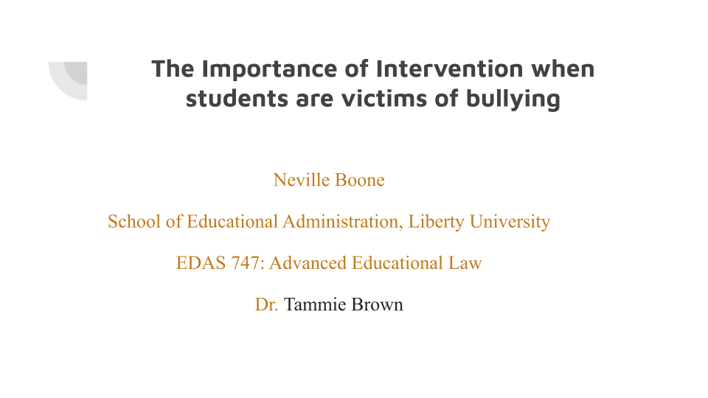
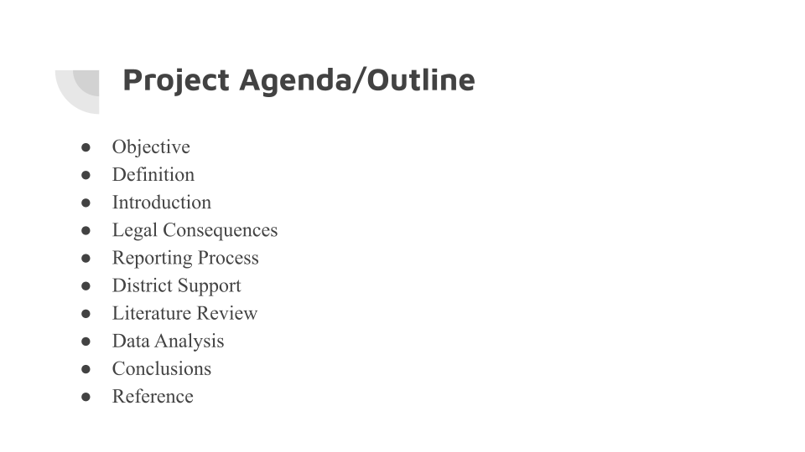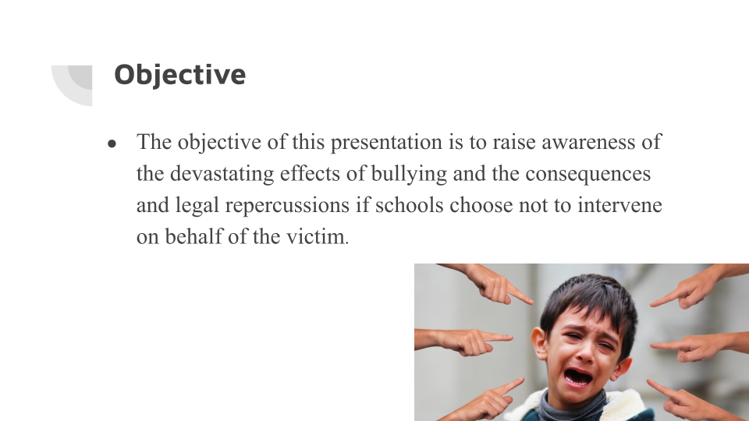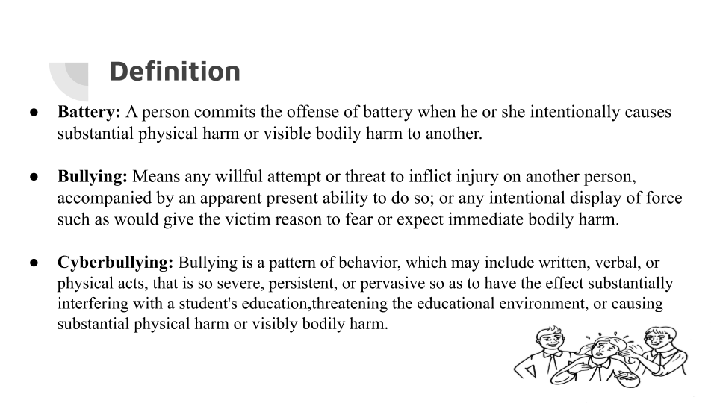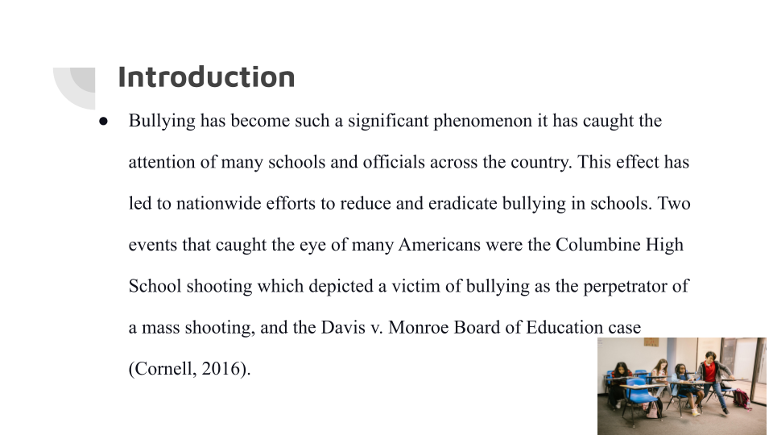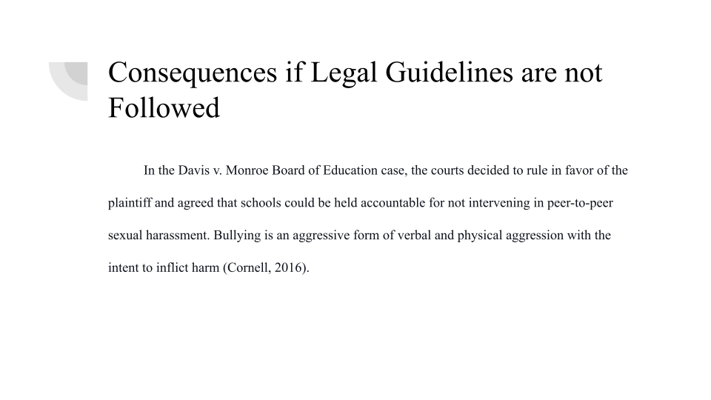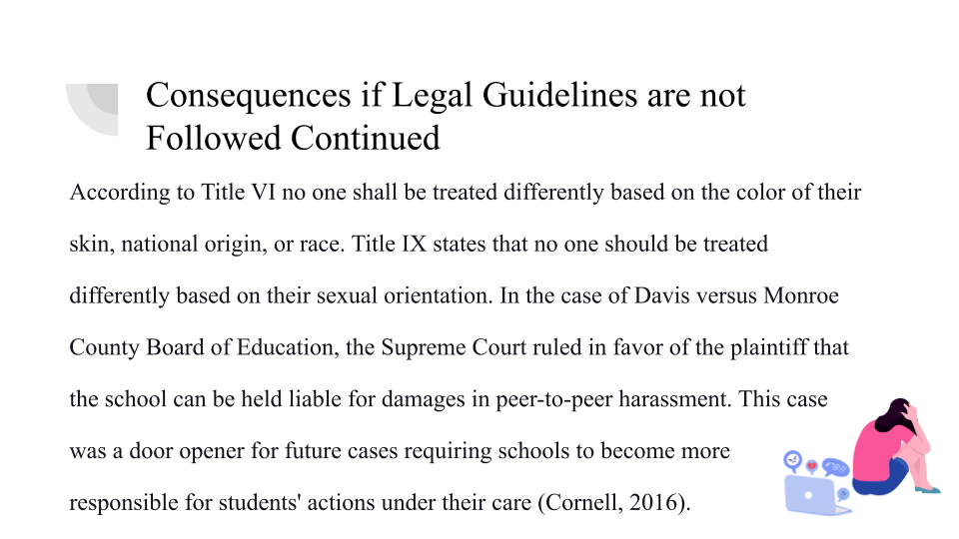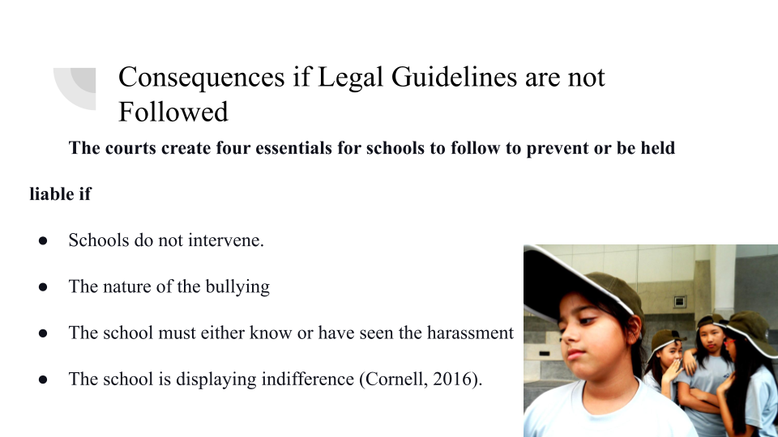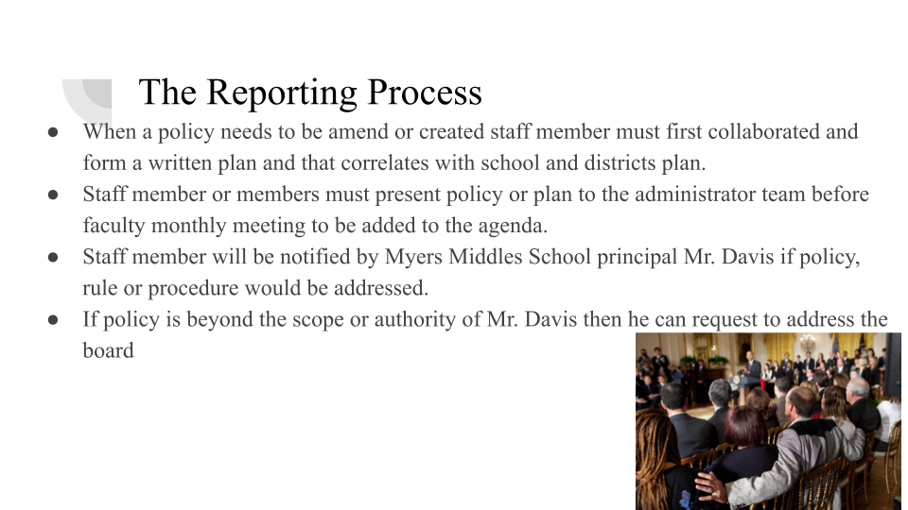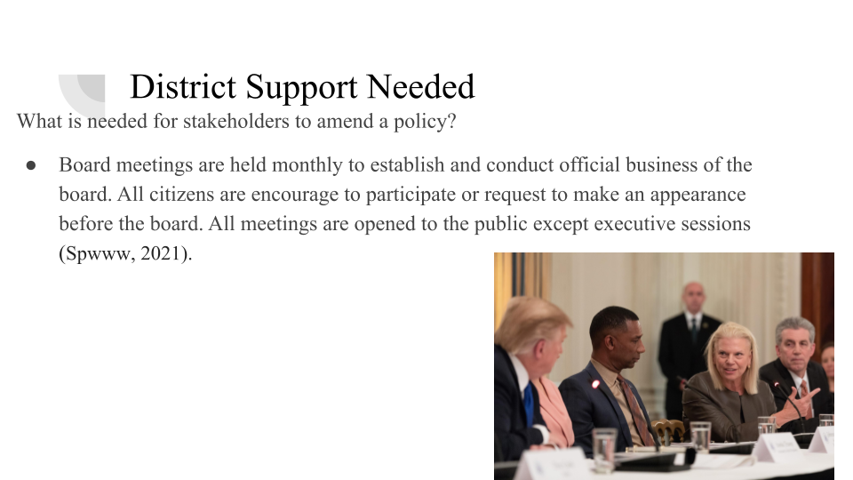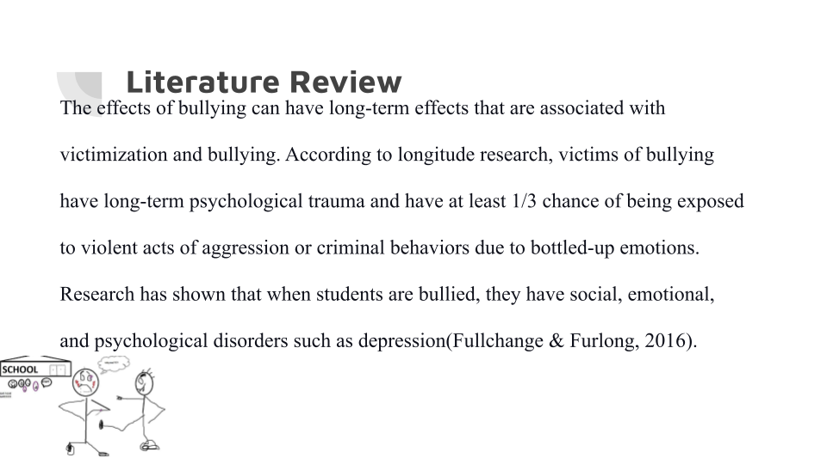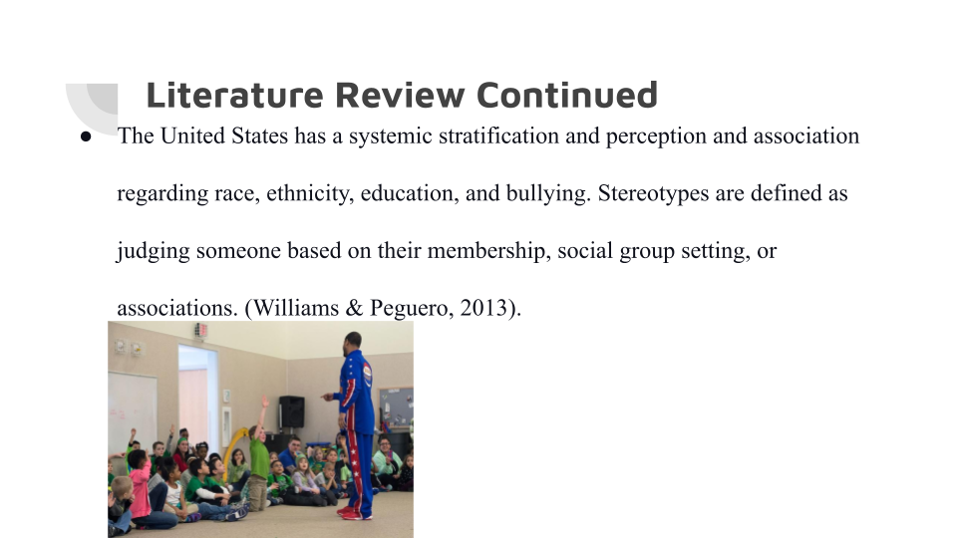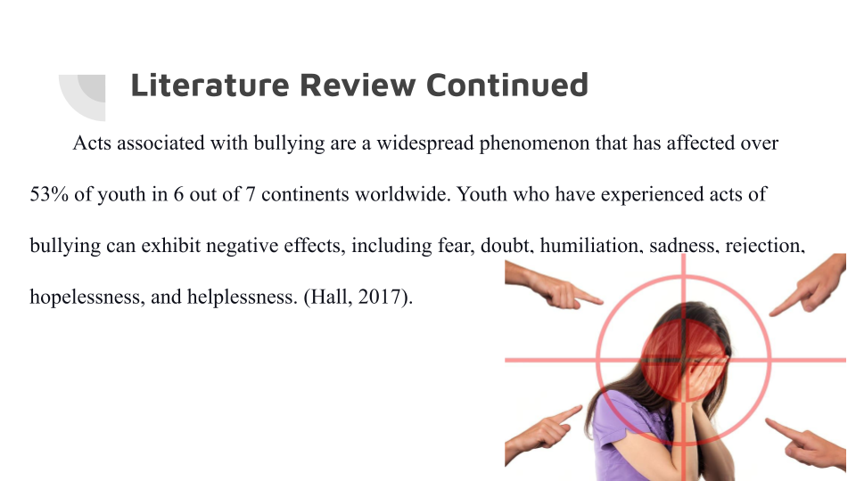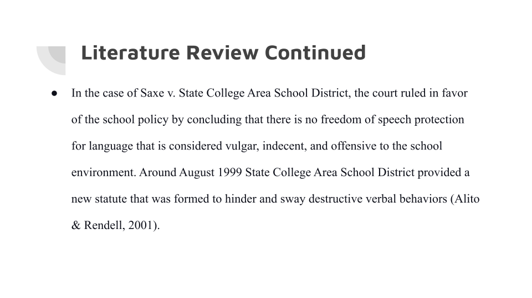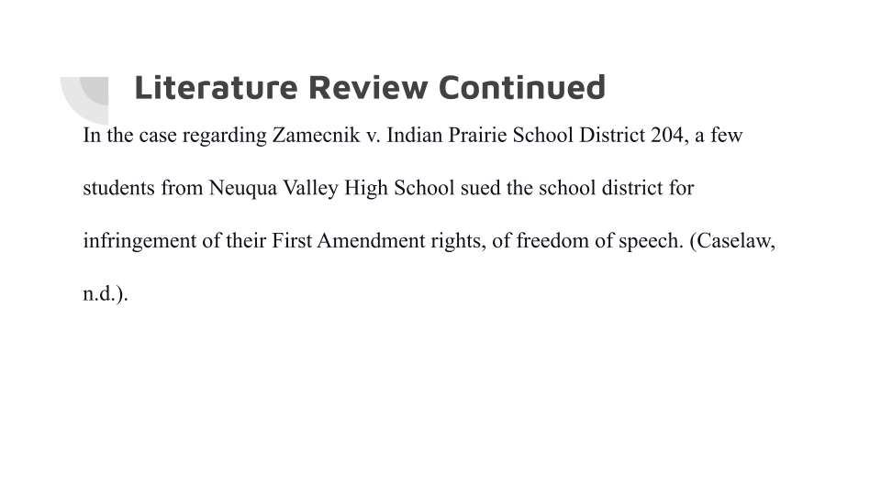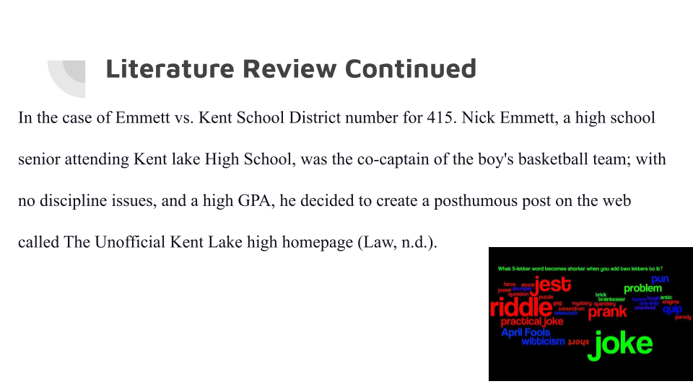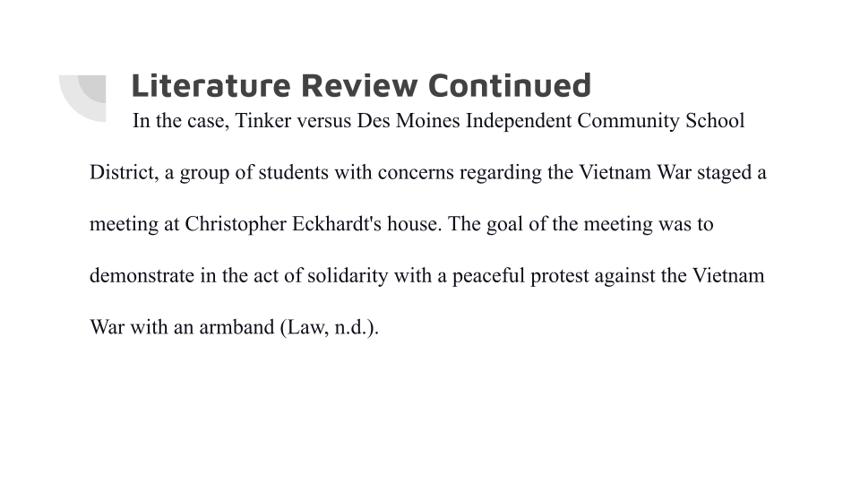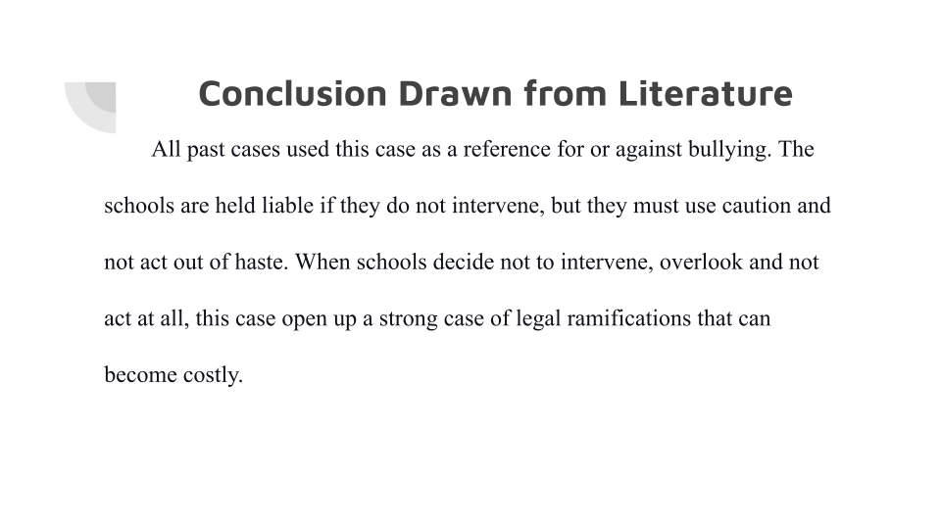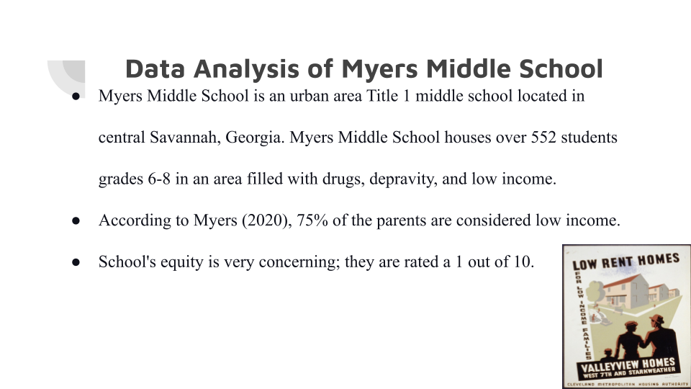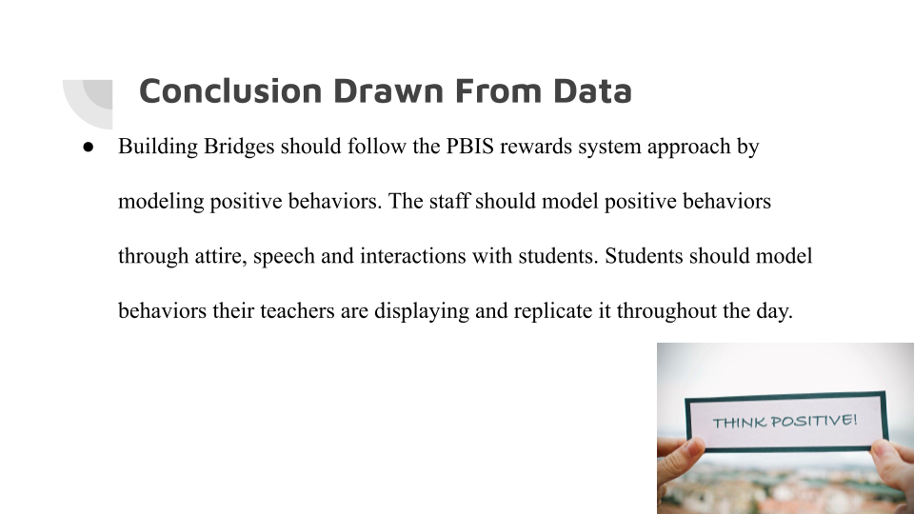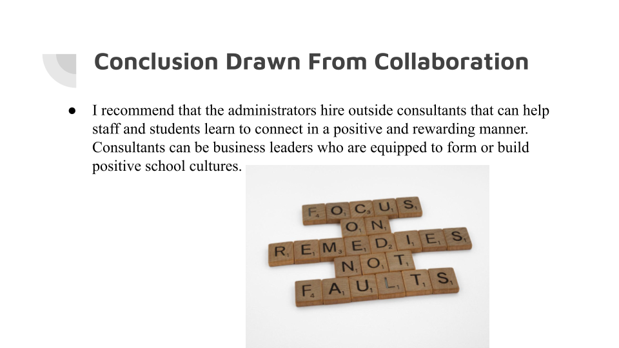

References

Alito, C., & Rendell, C. (2001). Saxe v. state college area school district. Retrieved April 13, 2021, from https://casetext.com/case/saxe-v-state-college-area-school-district/?PHONE_NUMBER_GROUP=P
Assistant Secretary for Public Affairs (ASPA). (2019). Federal laws. Retrieved April 15, 2021, from https://www.stopbullying.gov/resources/laws/federal
Caselaw. (n.d.). FindLaw's United States Seventh Circuit case and opinions. Retrieved April 13, 2021, from https://caselaw.findlaw.com/us-7th-circuit/1557587.html
Zamecnik v. Indian Prairie School Dist. #204, 636 F.3d 874, 876 (7thCir. 2011).
Caselaw.findlaw.com. (n.d.). FindLaw's United States Fourth Circuit case and opinions. Retrieved April 11, 2021, from https://caselaw.findlaw.com/us-4th-circuit/1575495.html
Charles, K. (2003). Gendelman v. Glenbrook North high school. Retrieved April 11, 2021,
from https://casetext.com/case/gendelman-v-glenbrook-north-high-school
Cornell, D. (2016). Do U.S. laws go far enough to prevent bullying at school? Retrieved April 11, 2021, from https://www.apa.org/monitor/2016/02/ce-corner
Edlawcenter.org. (n.d.). L.W. v. Toms River Regional Schools Board of Education. L.W. v. Toms River Regional Schools Board of Education. Retrieved April 11, 2021, https://edlawcenter.org/assets/files/pdfs/bullying/LW%20decision.pdf
Fullchange, A., & Furlong, M. J. (2016). An exploration of effects of bullying victimization from a complete mental health perspective. SAGE open, 6(1), 215824401562359. doi:10.1177/2158244015623593
Hall, W. (2017). The effectiveness of policy interventions for SCHOOL bullying: A systematic review. Journal of the Society for Social Work and Research, 8(1), 45-69. doi:10.1086/690565
Law.Justia.com. (n.d.). Emmett v. Kent SCHOOL dist. No. 415, 92 F. Supp. 2d 1088 (W.D. wash. 2000). Retrieved April 13, 2021, from https://law.justia.com/cases/federal/district-courts/FSupp2/92/1088/2529495/
Myers Middle. (2020). Explore Myers middle school in Savannah, GA. Retrieved March 28, 2021, from https://www.greatschools.org/georgia/savannah/341-Myers-Middle-School/
Oliveira, F., Menezes, T., Irffi, G., & Oliveira, G. (2017). Bullying effect on student's performance. Retrieved March 28, 2021, from
Student code of conduct. (2020). Savannah Chatham county public schools student code of conduct. Retrieved 2021, from https://spwww.sccpss.com/District%20Public%20Forms/Student%20Code%20of%20Conduct.pdf
Supreme.com. (n.d.). Tinker v. Des Moines independent Community school District, 393 U.S. 503 (1969). Retrieved April 13, 2021, from https://supreme.justia.com/cases/federal/us/393/503/#tab-opinion-1947775
Weinstein, J. (2014). T.K. v. New York City Department of education. Retrieved April 11, 2021, from https://casetext.com/case/tk-ex-rel-lk-v-nyc-dept-of-educ
Williams, L. M., & Peguero, A. A. (2013). The impact of school bullying on racial/ethnic achievement. Race and social problems, 5(4), 296-308. doi:10.1007/s12552-013-9105-y

