What's happening

School Clubs and Teams
Beta Team, Drama Club, Chorus, Band Basketball, Football, Tennis, Swim, Lacrosse and more.

PTO Store P.O.C

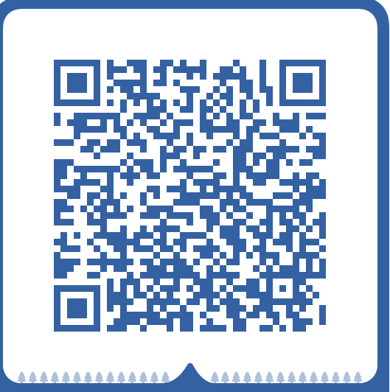

Staff directory
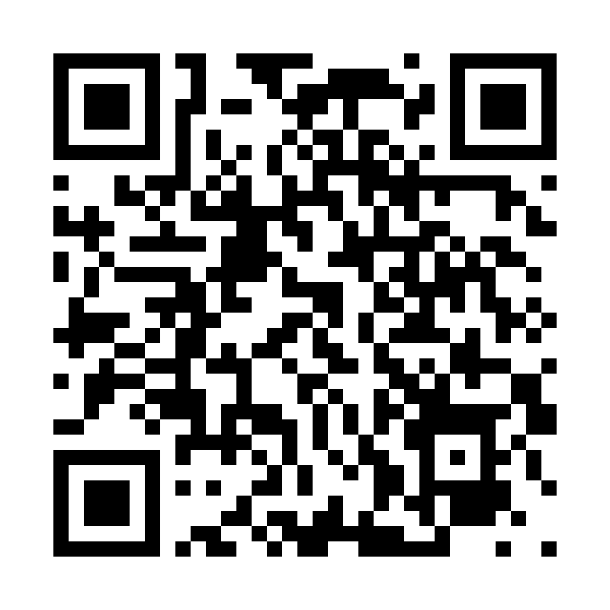

Students ELA Met or Exceeded Expectation
School 61.5%
District 37.5%
State 46.6%

Student Math ELA Met or Exceeded Expectation
School 42.1%
District 29%
State 38.9%
  - State of the school- 345 students
  - Cool Schools 2022-2023 Recipient
  - Runner up for Best Middle School from Post and Courier- Myrtle Beach
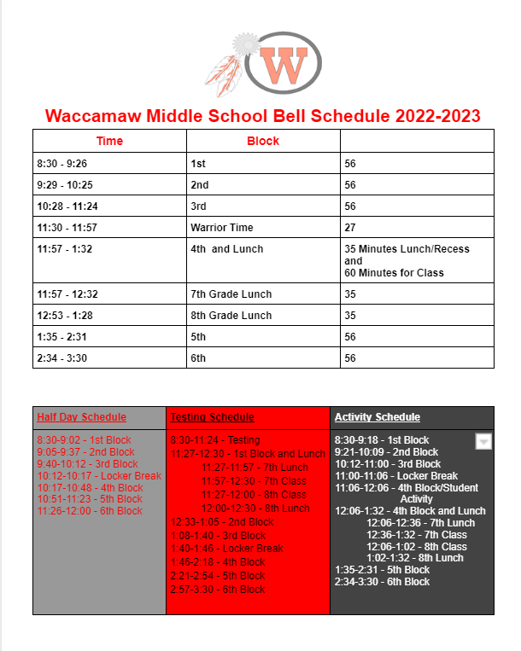

School improvement Council Members
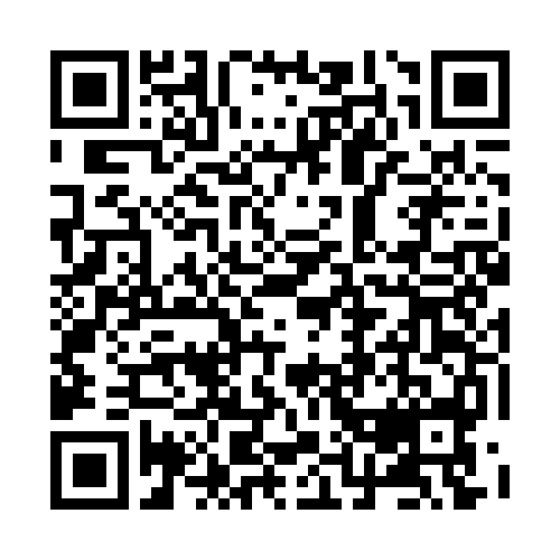

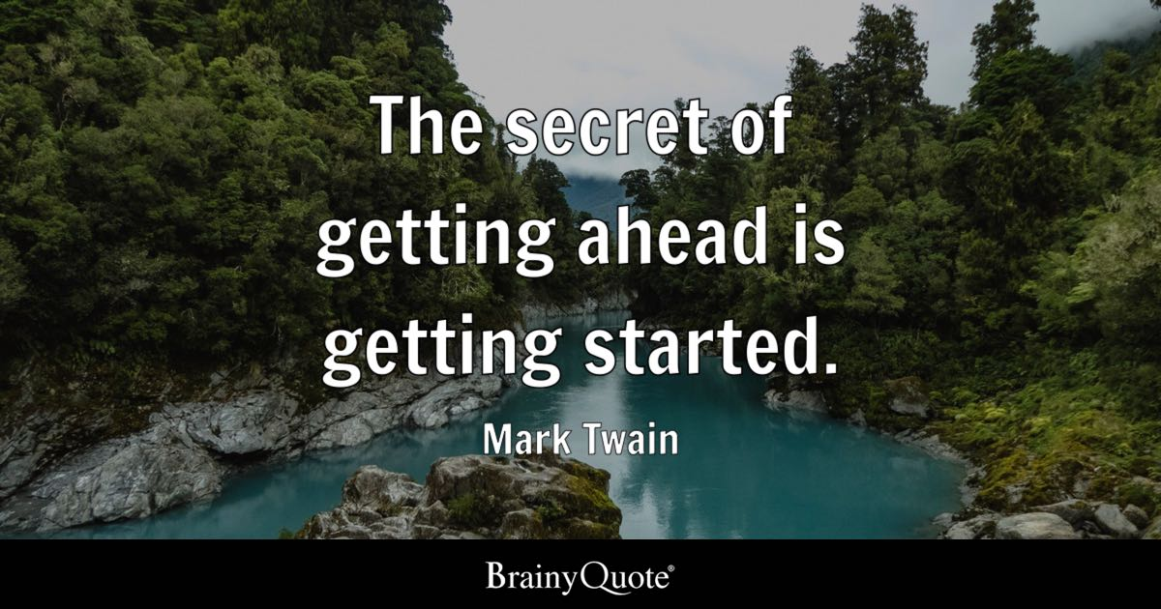

Come Join Our Family!



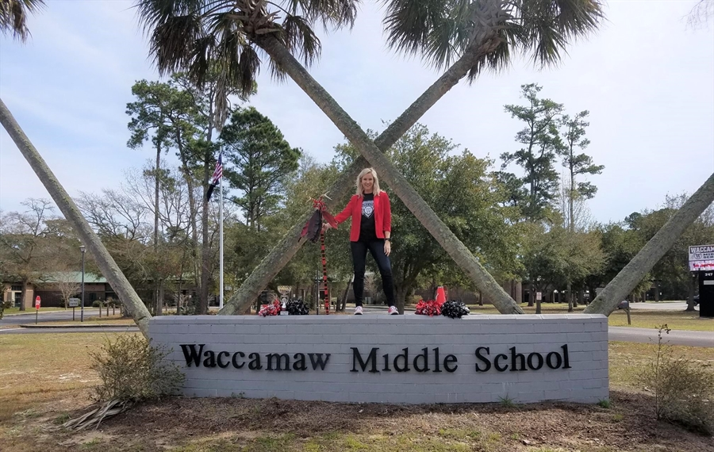

WACCAMAW MIDDLE SCHOOL

Welcome to Waccamaw Middle School Warriors! We are so excited to have you a part of our family and hope you will enjoy being a part of our tribe. The vision of Waccamaw Middle School is to become a unified tribe of Warriors discovering how to learn, take ownership, develop pride in our school and community while becoming productive, successful citizens. The faculty and staff at WMS is committed to maintaining and achieving high academic standards, creating a school culture that supports and challenges all students, and providing the foundational skills for students success.

Principal Ginny Haynes
ghaynes@gcsd.k12.sc.us
1843 237-0106

Chairperson and P.O.C Amy Bashor


Mission Statement
Mission
The mission of Waccamaw Middle School is to ensure that every student has the skills to build a strong academic, athletic, and artistic foundation by providing a rigorous, standards-based curriculum that meets individual needs and is delivered in a safe environment by a dedicated, caring staff.

Vision, Values, and Beliefs
Vision
The vision of Waccamaw Middle School is to provide diverse and challenging educational opportunities that prepare all students to be responsible, productive citizens and lifelong learners.

WMS MOTTO
Waccamaw Middle School, where the student comes first.

Frequently Asked Questions
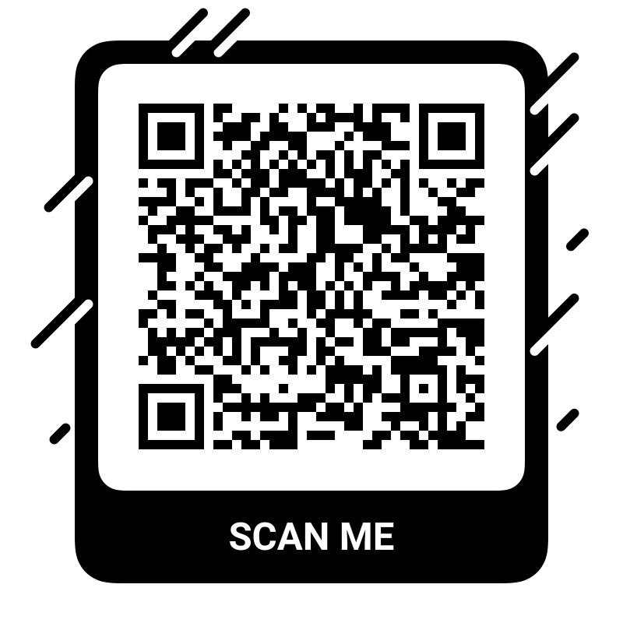
If you have a question about attendance, report cards and bus scheduling
please contact Ginny Haynes at ghaynes@gcsd.k12.sc.us
1843-237-0106
If you have a concern about power school, school safety, students code of conduct, please contact Mitch Meyer at mmeyer@gcsd.k12.sc.us,
If you have a concern about power school. School grades, Technology, Testing
Contact Christy Harrelson
Charrelson@gcsd,k12.sc.us
School Safety Officer Cclopez@gcsd.k12.sc.us or look here https://wms.gcsd.k12.sc.us/home
For technology support please contact Rebecca Adams@gcsd.k12.sc.us, School Safety

Come join our Family!
Our Title IX and Section 504 School Coordinators are as follows:
Athletic Coordinator | Section 504 School Coordinator
Calvin Brown | Mitch Meyer
247 Wildcat Way | 247 Wildcat Way
Pawleys Island, SC 29585 | Pawleys Island, SC 29585
Email:  Crbrown@gcsd.k12.sc.us | Email: ghaynes@gcsd.k12.sc.us
Telephone: 843-237-0106 | Telephone: 843-237-0106
Waccamaw Middle School Notice to the Public - Title IX and Section 504 - English Version
Waccamaw Middle School Notice to the Public - Title IX and Section 504 - Spanish Version
If you would like to volunteer for school related activities ghayneskylievaughn12@yahoo.com
If you would like to Volunteer for school store please contact Mrs. Vaughn, and Mrs. Bly at
kylievaughn12@yahoo.com
Kaneekaaj22@gmail.com
Math Department Mrs. Gabriel
Igabriel@gcsd.k12.sc.us
Business Department Mr. Boone
Nboone@gcsd.k12.sc.us
Science Department
btester@gcsd.k12.sc.us
Counseling Mrs. Williams
kiwilliams@gcsd.k12.sc.us
Sped Department Mrs. Gulley
jagulley@gcsd.k12.us.sc
please contact or look here ...........................
..................
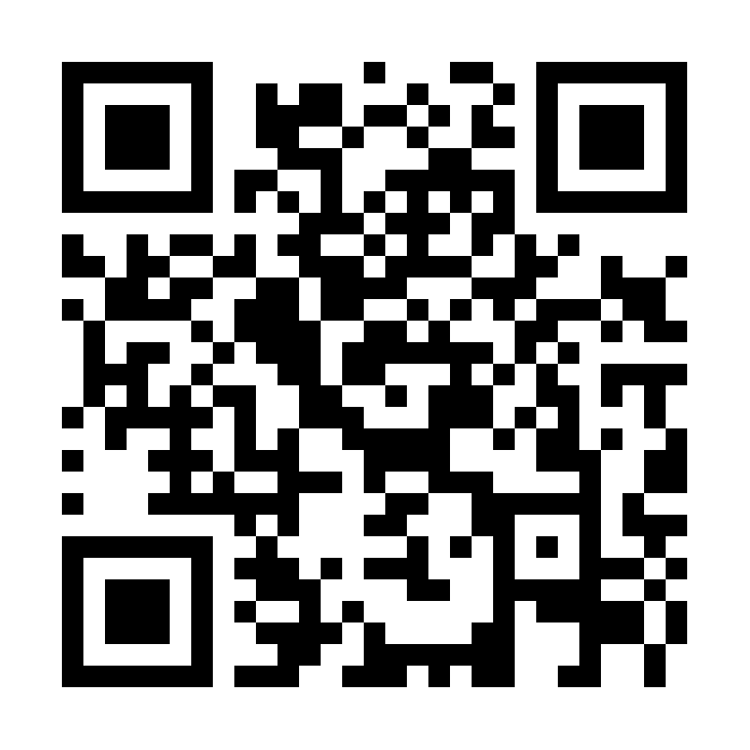
Come join our Family!

