Descriptive Statistics
- Answer the following questions using the table and data below:
I used a handheld calculator, but I wrote the steps out to each problem and how I solved them.
- What is the mean age of this sample? 47.5 What is the standard deviation? 10.75

- Create a frequency distribution table for denomination
Mark Tally Frequency
1 | 1 | 1
2 | 11 | 2
3
4 | 11 | 2
5 | 1 | 1
6 | 111 | 3
7 | 111 | 3
8 | 1 | 1
9 | 111 | 3
10 | 111 | 3
11
12 | 1 | 1

- What is the percentage of people who identify themselves as Baptist in this sample?
(3/20=0.15=15%)
15%
- What is the mode of church attendance?
5 = the mode occurs the most frequently. Twice a week.
The table below presents data for a sample of people who completed a religious survey.
Age | Gender | Denomination | Church Attendance
56 | 1 | 7 | 4
46 | 2 | 6 | 5
49 | 2 | 6 | 5
49 | 1 | 1 | 5
27 | 2 | 9 | 5
51 | 1 | 4 | 2
47 | 2 | 2 | 3
67 | 1 | 5 | 4
49 | 2 | 2 | 6
33 | 1 | 12 | 6
55 | 2 | 9 | 5
40 | 1 | 7 | 5
62 | 1 | 8 | 6
47 | 2 | 6 | 3
56 | 2 | 9 | 5
22 | 1 | 10 | 2
50 | 2 | 4 | 5
51 | 1 | 10 | 6
50 | 1 | 7 | 6
43 | 1 | 10 | 3
In this table, the numbers in the gender, denomination, and church attendance columns represent the following:
Gender
- Male
- Female
Denomination
- Episcopal
- Lutheran
- Methodist
- Presbyterian
- Other Mainline Protestant
- Baptist
- Other Evangelical Protestant
- Pentecostal
- Charismatic
- Non-Denominational
- Catholic
- Other
Church Attendance
- Less than once a month
- Once a month
- A few times a month
- Once a week
- Twice a week
- Three or more times a week
- The results of a recent survey indicate that the average new car costs $23,000, with a standard deviation of $3,500. The price of cars is normally distributed.
- What is a Z score for a car with a price of $33,000?
Z= x- k/y
Z=33,000-23,000/3,5000
Z=2.86
- What is a Z score for a car with a price of $30,000?
Z=X-k/y
Z=30,000-23,000/3,500
Z=2
- At what percentile rank is a car that sold for $30,000?
0/427725+0.50=0.97725
0.97725x100=97.73

- In one elementary school, 200 students are tested on the subjects of math and English. The table below shows the mean and standard deviation for each subject.
Subject | Mean | SD
Math | 67 | 9.58
English | 78 | 12.45
One student’s math score was 70 and the same student’s English score was 84. On which exam did the student do better?
The student did slightly better in English

For Math: z=(70.67)/9.58 x=0.31 percentile 62.17
X=70
Mean= 67
Sd=9.58

For English z=(84-78)/12.45 x=0.48 percentile= 68.44
X= 84
Mean= 78
Sd= 12.45

- Suppose you administered an anxiety test to a large sample of people and obtained normally distributed scores with a mean of 45 and a standard deviation of 4. Do not use the web calculator to answer the following questions. Instead, use the Z distribution table below and Appendix A in the Jackson text.
- If Andrew scored 45 on this test, what is his Z score?
Z=0
X=mean/sd=0
X=45
- If Anna scored 30 on this test, what is her Z score?
(30-45)/2
Z=-3.75
- If Bill’s Z score was 1.5, what is his real score on this test?
1.5=x=45/4 (1.5)4=(X-45/4)4 6=x-45+ 6+45=x x=51

- There are 200 students in a sample. How many of these students will have scores that fall under the score of 41?
Z= -1=.159
.159-200(people in the survey)= 31.8= 32
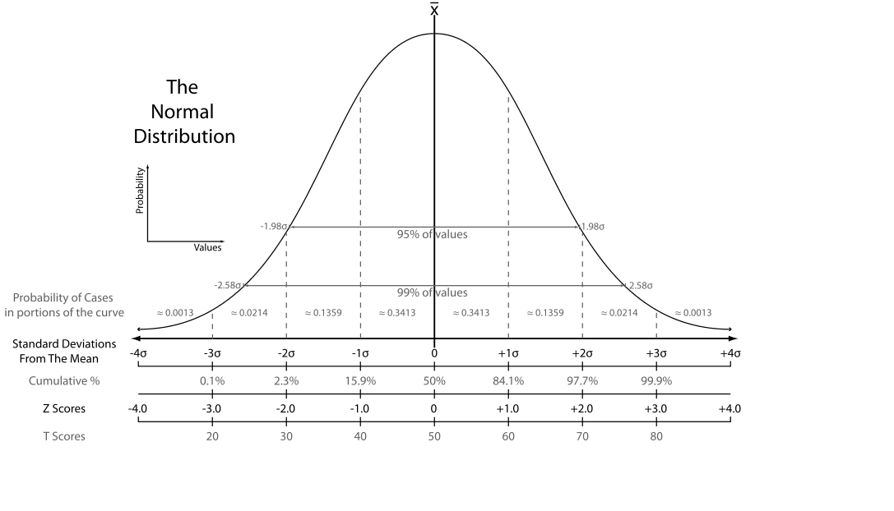

Lauren Wilson
Paper Proposal Methods
December 10, 2019

Abstract
This paper is going to explain the research behind the social media tweets and re-tweets with young girls on twitter. These girls have an obsession with losing weight, going on extreme diets, and starving themselves in order to become skinny. It will discuss the population of teenage girls who obsess with weight and how “skinny” social media influencers take a toll on the mental well- being of these teenage girls. This paper will show the side effects an obsession with weight loss and getting skinny can cause and how eating disorders can be formed through the presence of a social media influencer. It’s also going to discuss the qualitative research design in order to research how and why. This paper will discuss the group research procedure on how the researchers will show the mental state of these girls’ minds and what they are going through. In conclusion the paper will discuss the severity of the girls eating disorders and mental state of their minds.

Population and Sampling
The topic and particular population and sampling was the obsession that girls had with their body and the particular social media platform of wanting to be “skinny”. The particular study wanted to collect and do research on the particular population of young girls on social media that wanted to be skinny, go on extreme diets, or wanted to lose large amounts of weight in order to be “skinny” in society. The researchers pulled tweets from young girls that wanted this “skinny body” and that’s how the research started. The criteria for this particular research was young girls that have developed eating disorders, on the verge of wanting to change their body, or wanting to lose extreme weight in order to get a skinny body.
The tweets and re-tweets from these girls gave the researchers a start to discovering what the girls were facing by wanting a skinny body, and the extreme measures and diets that they are willing to take to get these bodies. According to the article, I Just want to be skinny.": A content analysis of tweets expressing eating disorder symptoms. researchers have examined how popular ED-associated hashtags and keywords may be distinguishable from one another by qualitatively coding and comparing their most popular themes. Results demonstrated that online posts which included the terms #thinspiration, #fitspo, and/or #fitspiration were qualitatively different from one another in how frequently they portrayed thin and objectified bodies and/or bone protrusions versus muscular, in-shape, and/or fit bodies [3, 6–9]” (Cavazos-Rehg, 2019). This gave the researchers an idea of the particular and what their research would involve.
The researchers pulled from tweets and re-tweets so they knew firsthand what they were going to be researching and the population that they were going work with. The researcher will not personally know any these girls, but will mainly do the research by the information and the persona that these girls have created by tweeting and re-tweeting about eating disorders and other extreme ways to lose weight and become skinny.
The particular tweets and re-tweets are going to show the researchers the correlation between the young girls and their obsession with weight and how the message, tone, and the particular tweet will affect them mentally by wanting to lose weight or have a particular body. The population and sampling is going to give people an understanding of what teenage girls want their body to look like and the extreme measures they will go to look a certain way and think a certain way. This is done by researchers looking firsthand at how society affects the mental health of teenage girls who are influenced by social platforms to look a certain way and the extreme measures that they are willing to go to have a certain body or look a certain way.
Instrumentation

The chosen instrument that is portrayed in this particular study is qualitative research design. This particular instrument was chosen in order to give the researchers insight of “why” and “how” these young girls are tweeting these messages of wanting to be thin and going to extreme levels in order to have a certain physique. By allowing the researchers to do the qualitative study it will answer the question of why these girls want a particular body. Qualitative research was the best design to understand these teens obsession with dieting and wanting to be skinny. According to the article, “Critically appraising qualitative research it states”, “an understanding that qualitative research is based in experience and in the construction of meaning, combined with the specific research question, should guide the sampling process (Kuper 2008). The qualitative design in this research played a role in helping the researchers guide the question of why girls want to be skinny and how society is negatively affecting girls’ self-esteem by portraying skinny and good looking social influencers.
The research will show that the underlying meaning to these tweets is wanting to look like social influencers. It also shows that society thinks an attractive woman should have a very thin body. The qualitative study will answer the question of how society is affecting young girls and the messages that are getting distributed in the media. It will show how young girls are viewing themselves and the extreme measures they are taking in order to obtain this “perfect” body. It will also show how it is negatively affecting their mental health by going on these extreme diets or trying extreme, dangerous ways to have a body like these social influencers that they see on social media platforms.
Procedures
This will be a group test design. The participants are selected through their twitter presences and what they tweet and retweet and how it effects their mental state of mind. This will be a group test design because the researchers are researching the tweets and re-tweets about young girls wanting to look like social media influencers and how it has affected their mental state. The procedure is a group test design because as a group these girls are tweeting about losing extreme amounts of weight, going on strict and scary diets, and cutting calories. The group design will test how all of these social media influencers are affecting these young girls that still developing and how watching, looking, and listening to these social media influencers affects them mentally by going on these extreme diets. The study will have results and percentages by looking at their tweets and retweets talking about body image and their self-esteem. This will give the researchers an idea of how to portray social influencers and how their power in the media is negatively affecting these young girls. The qualitative research design will help as well during this procedure. By using the group test design the researchers can go back and look at the designs of how it was affecting the girls on the “why” factor of understanding the reasoning behind the girls’ tweets and obsession with extreme dieting and weight loss. The procedure will help reach a certain group of girls that are affected by the influence of social media influencers.
Analysis
The analysis section will discuss how the data will be collected during the study and it will be analyzed to help researchers understand the severity of the girls eating disorders and how the eating disorders affect their daily lives and their feelings about their bodies.
A one sample t- test will be used by the researcher. This will allow the researcher to test whether a sample means significantly differs from a hypothesized value. This will also help the researchers gain a better understanding of how the psychological brain of a young teenage girl can be influenced by these social media influencers and the extreme weight loss they want to achieve in order to look skinny and fit. This can be compared to the hypothesis. The results can be used to find better ways to help young girls recover from using media to have skinny, slim bodies, and also how to help young girls recover from eating disorders.

Reference
Cavazos-Rehg, P. A., Krauss, M. J., Costello, S. J., Kaiser, N., Cahn, E. S., Fitzsimmons-Craft, E. E., & Wilfley, D. E. (2019, January 16). "I just want to be skinny.": A content analysis of tweets expressing eating disorder symptoms. Retrieved from https://search-proquest-com.ezproxy.liberty.edu/docview/2167792745?pq-origsite=summon
Kuper, A., Lingard, L., & Levinson, W. (2008, August 7). Critically appraising qualitative research. Retrieved December 10, 2019, from https://search-proquest-com.ezproxy.liberty.edu/docview/1778015911?pq-origsite=summon

