Accountability Protocol Project Template
The Accountability Protocol Project (APP) will demonstrate your ability to identify a data-informed problem of practice at your internship site, making data-driven decisions by setting goals and developing effective strategies to improve the problem of practice through training and professional development. The multiple activities of the APP are scaffolded, building upon one another. Each activity is to relate to all the others. Below are the various activities that make up the project.
- A formal and acceptable paragraph is a minimum of five (5) full sentences. Please type your answer following each posed question. Remove any automatic number when you insert your answer into the template.
- All links/attachments provided by the student must be functioning links and/or accessible attachments. Please clearly label your attachments (e.g., Part 1_Quantitative Data).
- This project is required to be completed using this template with submission on Canvas and on CORE along with all applicable attachments.
- Refer to the Accountability Protocol Project Instructions for the Project Rubric.

PART 1: Data Collection, Data Analysis, and Guiding Question: In collaboration with the onsite mentor, school leadership, and faculty members, interns will demonstrate the capacity to develop and lead improvement processes through the use of data by designing a measurable guiding question and at least one goal that addresses a problem of practice at the internship site. The goal is to be aligned with current school-improvement processes (NELP 1.2).
(a) Quantitative and Qualitative Data Collection and Analysis

- Provide a 1-2 paragraph narrative detailing quantitative data collection and analysis, explaining how the data inform the need for improvement. Attach data as evidence.

In searching for quantitative data, I began my search for information by utilizing the Raleigh County School district’s attendance office, the administrative website known as WVEIS, attendance data and information from my own high school, statewide attendance data from the WVDE, state and local media resources, and through the County’s pupil services office. At all levels, I felt as though a clear correlation could be made between student attendance and the graduation rate. For instance, in the state of West Virginia, the overall attendance rate for this past year’s 2023 graduating class was 91.3% and the graduation rate was 92.6%. By comparison, for Raleigh County Schools, the overall attendance rate, for the same cohort was 91% and the graduation rate was 89.9%. Finally, for Shady Spring High School, the overall attendance rate was 91.81% and the graduation rate was 92.26%.

Part 1.a.1_Quantitative Data attachment-
West Virginia, Department of Education Zoom WV – Attendance Data
https://zoomwv.k12.wv.us/Dashboard/dashboard/2174

- Conduct interviews with the onsite mentor, a teacher, and a parent or student. Provide a 1-2 paragraph written analysis detailing qualitative data outcomes and how the data inform the need for improvement. Attach transcriptions of all three interviews as evidence. If necessary, research the difference between quantitative and qualitative data collection.

To gather qualitative data, I conducted an interview with my on-site mentor, one teacher, and one parent. Results of the interview show that each of the three had similar views in regard to attendance. Each one rated attendance among the highest indicators of academic success and similarly explained that culture and attitude tour attendance seem to play the largest contributor. When asked whether doctors note absences should be considered the same as an absence with a note from the parent, there was a little difference of opinion. The parent spoke up on behalf of parent notes and would later explain that not all illness required a visit to a doctor. However, the teacher and principal both felt that parent notes can sometimes be abused. All parties agreed the use of incentives to prevent chronic absenteeism was a good idea, but all agreed the same incentive could also prove counterproductive when a student would choose to come to school while ill rather than stay home until they are feeling better, and/or their fever had dissipated.

Part 1.a.2_Qualitative Data attachment- https://wvk12my.sharepoint.com/:w:/r/personal/dwbarnet_k12_wv_us/Documents/Attachments/Qualitative%20Data%20Collection%20Interview%201.docx?d=w1656f4fba9b7487fa69b5ccaddadba7a&csf=1&web=1&e=LP9EkI.

(b) Identify a Problem of Practice and Develop a Guiding Question

1) After researching and identifying a problem of practice, design a measurable guiding question that diagnoses the problem of practice using the quantitative and qualitative data collected in the previous step.

How can current data regarding attendance rates of the graduating class of 2027 be used to help identify trends and solutions for improving the graduation rate of the freshman cohort by three or more percent at Shady Spring High school compared to current graduation data?

2) Provide 1-2 paragraphs detailing a justification for the guiding question and how it aligns with the school’s mission, vision, and current improvement processes already in place at the school. This narrative should include how the data informed the selection of the guiding question (i.e., problem of practice).

As part of the school’s five-year plan, the attendance team has considered various ways to improve attendance numbers for all classes. Shady Spring High school currently maintains a rate of attendance of 93.137% for this year’s freshman cohort. Compared to the attendance rates of the sophomore, junior, and senior classes that are currently in the building, the freshman cohort attendance rate trails the sophomore group (94.175%), trails the junior group (94.673%), and leads the senior class (91.592%). To meet the goals of our five-year plan, I chose this problem of practice to gather information to analyze in hopes of improving overall attendance rates for the freshman, cohort, and their improving the graduation rate for this class as they moved forward over the next three years.

Part 1.b.2_Attendance data attachment-
West Virginia Department of Education Zoom WV
https://zoomwv.k12.wv.us/Dashboard/dashboard/2174

- Provide 1-2 paragraphs briefly detailing the plan for evaluating the successful implementation of the guiding question (e.g., math scores for 3rd grade students will increase by 5%).

To best evaluate the success or failure of this program, I have requested that data be collected and analyzed each semester by the members of the school attendance team and the school improvement committee. The overall progression toward the goal of an improvement of 3% for the freshman cohort and their graduation rate in three years can be accurately monitored, analyzed, and adjusted as needed in this manner. This process will be reviewed each semester. Results will be analyzed by the attendance team and shared with faculty and staff. Ongoing review will be further shared with county attendance director.

(c) Goal Setting
- Develop at least one strategic and tactical goal that aligns with the guiding question and informs improvement.

One strategic goal that would align with my guiding question could be to implement a policy of meeting with parents/custodians of any student whose own attendance rate might fall below 90% (5 or more absences) within any given nine weeks grading period or 10 days per semester). One tactical goal might be to convene and utilize a student support group to provide encouragement for better attendance, as well as tutoring, if needed for the students in question.

- Provide 1-2 paragraphs discussing the alignment of the goal(s) with the guiding question and the data and how it informs improvement.

Implementation of either the strategic, and or tactical goals would help monitor potential issues regarding attendance and would hold in place the means to help address and improve potential attendance troubles for our students. Combined with the goal of 3% improvement in the graduation rate of our freshman cohort, all gathered data could be used to identify potential problems, provide potential supports and solutions for the improvement of both attendance goals, and the graduation rate. By keeping an alignment between the goals, and the guiding question, data will be more carefully and concisely, analyzed and supported. Focused alignment will guide successful improvements in attendance data. Improved attendance will prove to be the most common and most important factor in the rise of graduation rates and student success.

- In 1-2 paragraph(s) discuss how the guiding question and goal(s) align with current improvement processes at your site.

Currently, my school, and more specifically, our attendance team, has identified at-risk attendance issues as a major contributor found in most of the dropouts, we have had over the past several years. Current efforts to improve attendance, include the use of various incentives and rewards for high attendance rates for our student body. A county initiative that allows students with high academic achievement combined with few absences over the course of grading period to be exempted from semester exams has been used for a few years since COVID. Results and impressions are mixed. Those in favor of this incentive remark of the positive rewards it encourages. Opponents of the incentive note that students sometimes will come to school when sick rather than staying home until they feel better; sometimes causing further spread of illness. At any rate, moving forward with this project, I hope to discover some alternate options for attendance incentives that will benefit students, parents, and schools alike.

See attachment-
Part 1.c.3_Community Schools Attachment
WVDE Policy 2425- Community Schools: Promoting Health, Safety, Well-Being and Academic Success of Students
https://apps.sos.wv.gov/adlaw/csr/readfile.aspx?DocId=25989&Format=PDF

PART 2: Accountability Protocol: In collaboration with the onsite mentor, school leadership, and faculty members, interns will demonstrate the capacity to evaluate, develop, and implement a system of supervision, support, and evaluation designed to promote school improvement and student success (NELP 7.4).
- Evaluation of District Policies and Instructional Expectations

- In 1-2 paragraph(s) discuss district policies and instructional expectations related to your guiding question and goal(s). Include evidence by attaching or linking policies reviewed.

According to West Virginia Department of Education Policy 4110, students are expected to be in attendance of school as much as possible. Students are granted up to five days per semester before any type of notification or remediation would become involved. A note from a doctor is required. Anytime absences would exceed more than three consecutive days or more than five days in a semester. Absences are excusable under hazardous conditions, physical illness of the student, death and immediate family of the student, observance of religious services, leave of educational value with approval of the school, principal, and or other private or religious school instructional purposes.

Part 2.a.1_ Attendance Policy Attachment
WVDE Policy 4110- Attendance
- https://apps.sos.wv.gov/adlaw/csr/readfile.aspx?DocId=53931&Format=PDF

- In 2-3 paragraphs, discuss teacher supervision, support, evaluation, and instructional processes in place at your site and how these relate to your guiding question and goal(s). Include evidence by attaching or linking instructional policies reviewed and current forms or processes used for teacher supervision, support, and evaluation.

My internship site, attendance rates are monitored by the principal, the school, attendance team, and updated daily by our school secretary. Information regarding data rates is loaded into the WVEIS system each day, and onto a site called ZoomWV. For students with attendance issues, our County has an Attendance Director that can speak with the students and their parents to help rectify any problems or legal circumstances that may be forthcoming. Our school has a graduation coach assigned to work with our students as needed and we have a Community in Schools liaison on staff to ensure students have what they need to be successful in the classroom.

Part 2.a.2_State and County Attendance Data Attachment
- https://zoomwv.k12.wv.us/Dashboard/dashboard/2174

(b) Plan for the Assessment and Improvement of Teacher Performance
- After observing teachers in a variety of classrooms affiliated with the planned improvement process for your accountability project, in 2-3 paragraphs describe measures to assess teacher performance and how the implemented plan will provide actionable feedback to support the improvement goals of your project including how these align with district policies and instructional expectations.

In my school, teachers of all academic areas meet with students each day as part of their links program. minute homeroom group that is used to provide students with ongoing opportunities for tutoring services, college prep, testing information, to attend to any administrative issues that might arise, and it provides the opportunity to work on life and personal skills issues. Teachers are provided the framework in which to follow for student needs. Among the topics discussed and instructed during this program, attendance and truancy issues are covered and repeated, along with graduation requirements, and course information. Attendance data is also recorded for this course and students are periodically notified by their links instructor of their own attendance situation, and what affects it may be having on their academic success.

- In 2-3 paragraphs, detail plans for ensuring teacher growth based on the outcomes of the measures implemented for your accountability project.

Following implementation of my accountability Project, teachers met during Faculty Senate days to review student attendance data for their classes and discussion will be led regarding correlation of student tenants to their academic grades. The attendance team will meet with groups of teachers by department to determine whether policy adjustments are necessary, how to exact the changes needed, or if a more personal and family-oriented 1Qws∂cv meeting would need to take place. Teachers would be better able to initiate changes after having all information made readily available through the process.

(c) Plan for the Assessment and Improvement of Student Outcomes
- In relation to your guiding question and goals, describe in no less than one (1) paragraph the measures that will be used to assess student development needed to ensure improvement.

Student attendance and classroom success are also monitored by our counselors. Each semester, for each grade level, counselors meet with each student to discuss progress toward graduation credits, goals for post-secondary work or education, and if attendance issues are noted, changes in overall course progression can be adapted. But all students must meet with counselors each year to ensure they are on path to graduation. Absences are monitored by our attendance team. Any excessive numbers of absences will involve parent conference, counseling intervention, and a meeting with the county attendance director.

- In relation to your guiding question and goals, detail in no less than one (1) paragraph plans to evaluate the progress of student development.

As ongoing review of student data occurs, attendance information is shared between administration, graduation coaches, Links instructors, and classroom teachers. Any student identified as having attendance issues will be provided multiple opportunities and services to help remedy his or her situation. Documentation of process intervention will take place during each step of intervention. Links instructors go with their assigned student group for all four years of high school. This way they become more familiar with the students they serve. Up-to-date attendance information is readily available and will be evaluated and adjusted as necessary by all persons involved in the process throughout the student’s tenure in high school.

- In relation to your guiding question and goals, detail in no less than one (1) paragraph the plans for ensuring increases in student achievement.

In Raleigh County Schools, students are provided with a review of their earned graduation credits each year before they begin to design their academic program. Counselors ensure that all required courses are assigned and completed before being allowed to move onto optional required credits. Links instructors work along with counselors to ensure the student needs and wants are met to the highest degree possible. Parents are included in the PEP scheduling to ensure they have an understanding of the student’s situation, current standing, and academic goals. This process works to involve all parts of the students’ academic plan and keeps everyone informed at each step.

PART 3: Training and Professional Development: In collaboration with the onsite mentor, school leadership, and faculty members, interns will implement a training and professional development plan designed to promote reflection, cultural responsiveness, distributed leadership, digital literacy, school improvement, and student success (NELP 7.3).
(a) Planning for Professional Development
- In 1-2 paragraph(s) explain how your professional development plan for this project aligns with the data, the guiding question, and your goal(s).

Regarding my accountability protocol project, the results of my attendance and graduation rate study will be guided by information gathered by myself and the school attendance team throughout the semester. Weekly attendance reports identify those with excessive unexcused absences and are passed on to the appropriate assisting staff. This program also identified students at risk of not graduating on time due to attendance issues. This plan aligns with data collected by influencing and analyzing attendance trends and goals, leading to greater academic success, and in turn, greater graduation results.

- Evaluate the professional capacity of the staff and management practices of leadership; then in 1-2 paragraph(s), reflect on how these might influence improvement.

Staff at my school receive professional development opportunities throughout each semester. At the beginning of which school year three days are provided for unique topics to enhance teacher understanding. APL training is an opportunity for teachers to develop better classroom management strategies and interventions. It also provides training for counselors and teachers review and analysis. The school leadership and attendance teams monitor attendance and truancy issues and share the results with teachers during this professional development. At the school level, this information can be broken down and shared with classroom/Links teachers at the end of each nine-week grading period. Information will then be shared with students and parents. Our leadership does a great job of monitoring each of the sub-groups and committees within the school. All teachers are given the opportunity to help develop and manage programs to enhance and improve the student experience.

- In 1-2 paragraph(s), explain how your professional development plan for this project will promote teacher self-reflection.

As a result of monitoring student attendance information, teachers are expected to review and share any changes in policy. Teachers can utilize this time to self-monitor and reflect upon their lessons and effectiveness. Repetition of this information will provide teachers with chances to better prepare students for academic success and improve attendance as a result.

- In 1-2 paragraph(s), explain how your professional development plan for this project will promote cultural responsiveness.

Cultural responsiveness will increase because of a greater opportunity to learn and community involvement. Through the inclusion of parents throughout the students planning processes, all parties are better informed, and to some extent, develop ownership of the student’s educational plan. The community, as a stakeholder shares in the successes of all aspects in a school. Taking part in the process, parents and community members certainly help ensure the success of a school- one student at a time.

Part 3.a.4_Cultural Involvement Attachment
WVDE Policy 4200- Provision of Equal Opportunity in West Virginia Public Schools https://apps.sos.wv.gov/adlaw/csr/readfile.aspx?DocId=6275&Format=PDF

- In 1-2 paragraph(s), explain how your professional development plan for this project will provide opportunities for identifying and engaging staff in leadership roles.

All staff members that are willing to take part as a member of the attendance team are welcome to do so. As interventions and changes are deemed necessary, sub-committees can break off to tackle smaller parts of the problem and then reconvene to a greater whole. As these individuals work on attendance issues and graduation rate improvement, they will identify problems, discuss how the problem came to be, develop appropriate changes to improve or provide a solution, and find ways to evaluate the program success or failure. This is a direct gain of experience in leadership and can be shared throughout the building by several individuals.

- In 1-2 paragraph(s), explain how your professional development plan for this project will utilize digital technology in ethical and appropriate ways to foster professional learning.

Digital technology can be utilized to quickly and efficiently to share information between the individual, the school, and the attendance office at our county Board of Education. Any changes or adjustments can be shared through email and data is readily accessible and easy to manage at the fingertips. Teachers will have access to all relevant information through the WVEIS program- ZoomWV. This information can be shared with students, parents, counselors, community-in-schools liaisons, academic and graduation coaches, and anyone else that may be part of the process.

(b) Professional Development Implementation
- In a bulleted or numbered format, outline a series of planned professional development activities informed by your data, guiding question, and goal(s) that support school improvement.

- Review of Freshman Cohort attendance data with Attendance Team
- Introduction to ZOOMWV with Raleigh County Attendance Director
- Departmental meeting- Review of WVEIS functions and data collection
- Attendance team meeting with Principal and Department Heads

- Develop a table that depicts a professional development schedule you will implement for this project that includes a list of dates, times, locations, etc.

Dates | Times | Location | Training
1/24/24 | 9:00-3:00 | Raleigh County Board of Education | Principal’s Meeting
2/19/24 | 8:00-4:00 | Shady Spring High School | Faculty Senate, Leadership Team, Attendance Team Meetings
3/12/24 | 6:00-8:30 | Raleigh County Board of Education | Meeting with Attendance Director and Assistant Superintendent
3/29/24 | 8:00-11:00 | Shady Spring High School | Leadership and Attendance Team Meetings
4/16/24 | 9:00-12:00 | Shady Spring High School | Training session with School Counselors and Principal

PART 4: Implementation of Accountability Project: In collaboration with the onsite mentor, school leadership, and faculty members, interns will implement the accountability protocol project at the site, developing and engaging staff in a professional culture designed to promote school improvement, teacher retention, and the success and well-being of each student and adult in the school (NELP 7.2).
(a) Implementation Details
- Describe in 2-3 paragraphs the details of the implementation of your accountability plan. Considering your data and observations, reflect on the successes and failures of implementation and how these may have impacted school improvement and the success and well-being of the students and teachers.

At the beginning of this accountability project, attendance rates and graduation rates in the county where I work were identified as having a need for improvement and there has been established a direct relationship between the two. Having spoken with my mentor, teachers in my building, our school attendance team, and our county attendance director it has been indicated at all levels, the importance of student attendance and its role in student success, and more importantly, upon the graduation rate. Raleigh County has introduced various attendance incentives over the past couple of years, aiming to repair damage done to school attendance and academic progress throughout the COVID experience.

Through implementation of my Accountability Protocol Project, we have collaboratively worked to improve academic successes, and have more effectively utilized having a Community-in-Schools liaison, the school attendance team, and have helped teachers, students, and families to better understand the need appropriate school attendance. One logo utilized by our school attendance team states, “In order to get there, you have to be here!” I believe that is a very appropriate and incredibly accurate as it relates to student success. The project will prove to be more valuable as time passes on and more data is collected. But for now, successes include the utilization of knowledge in relation to what programs are available for students and families, community involvement in the operations of the school, and increased understanding of attendance issues and their direct effects on academic success.

Part 4.a.1_Graduation Requirements link.
Raleigh County Schools Graduation Requirements
https://core-docs.s3.amazonaws.com/documents/asset/uploaded_file/1868837/Graduation_Requirements.pdf

- Explain in 1-2 paragraph(s) how the implementation of your accountability project impacted teachers and how it promotes teacher engagement and teacher retention.

I have found through implementation of this project that teachers are being provided with accurate and up-to-date student attendance data. Beyond what goes on in their day-to-day classroom, teachers now have access to a more complete look at student attendance, and the correlation between their successes or failures in the classroom. Teachers are also provided an opportunity to speak with students and the school attendance team in order to better meet the needs of the students in question, provide meaningful feedback and conversation to the parents of the affected students, and have the opportunity to create positive change for the student and further own classroom. For our Links teachers, in particular, they have a of time spent with their homeroom students over a four-year period and will have ongoing data to recognize, identify, and help influence individual student attendance information as they get to know their students better during their time in high school. This rapport will help to retain teachers, as they take an extended sense of ownership in the process.

- Describe in 1-2 paragraph(s) how your comprehensive accountability project provided school community members with a healthy, professional, and culturally aware school environment.

Throughout project implementation I have been able to work with individual Links teachers, our administrators, and my County Attendance Director and a group of parents on the school’s Local Schools Improvement Committee (LSIC) committee to collaborate on incentive ideas, and how to possibly make them more meaningful and more flexible. One discussion we have had included providing more flexibility to students in the number of absences they have each semester. Teachers indicate throughout our building that sometimes students have shown up for class with high fevers, lots of flu type symptoms, and have come to school only to meet the requirements for some of our incentives. Other students have been exposed to the germ, flu, and as a result faced many absences on the run. Current policy allows for students to miss up to five days if they have an “A” in a course in order to be exempt from semester exams. The number becomes four absences with a “B”, three absences with “C”, or two absences with a “D”. These absences are for any absence. A recommendation was made was to allow for up to five absences with doctors exemption, death in the family, attendance of school function, and up to five separate parent notes for each semester. This recommendation is being currently debated at the School and County level.

Part 4.a.3_Attendance brochure link.
Raleigh County Schools
Student Attendance Brochure
https://core-docs.s3.us-east-1.amazonaws.com/documents/asset/uploaded_file/1847867/Attendance_Brochure_23-24.pdf

- In 1-2 paragraph(s) discuss the role of relationships, trust, and well-being in the development of a healthy and effective school professional culture and how you attended to these constructs during the implementation of your accountability project.

With any proposed change, there must always be debate and data. As result of this project, teachers and administrators at the elementary, middle, and secondary levels were interviewed for their professional opinions. That information was gathered and then discussed at length with our school, attendance team and administrators. Several of those members are also parents of students who understand policy, as well as personal reasons for their choices and stance. Again, I believe that all persons included or valued stakeholders, and should have some on policy as it pertains to their children and students. I believe that gathering opinions of those who share common affect responsibility works to build, teamwork, community support, and legitimate backing of policy. The development of trust is forged through cooperation at all levels. The inclusion of families in school decision-making is a huge, positive step that brings about change and encouragement. Teachers become empowered when given the opportunity to share thoughts and suggestions. Even student interaction leads to positive change within the school. All parties have been utilized throughout the project and have voiced appreciation for having been heard. I believe trust and relationships will be the cornerstone of the foundation of school leadership for me, moving forward.

(b) Collaboration
- Detail in 1-2 paragraph(s) how you collaborated about the data that informed the development of your accountability protocol project.

At the beginning of this project, I was able to attend a meeting with our county assistant superintendent of schools, and we spoke about the attendance situation at length. As a parent, I felt current policy needed to be a little more lenient as I believe some incentives tend to benefit students indirectly at the expense of other students. As a teacher, I feel there should be a difference between a commonly excused absence for illness, death in the family, injury, etc., compared to not feeling well and staying home with a parent note for documentation. This project has allowed me to gather the opinions of other professionals, administrators, and community members at large and to further value the importance of attendance throughout our community. I was able to gather and analyze data with a lot of help from my mentor, our assistant principals, and our teachers on both the attendance team and leadership team. It takes a village sometimes, and mine is strong.

- Detail in 1-2 paragraph(s) an explanation of how you collaborated on the implementation of your accountability protocol project at your internship site.

At the beginning of this project, after I had met with my mentor and discussed topic options for my guiding question for this project, I was able to join our local attendance team and begin compiling data for this project. After deciding upon the question and the focus of this project, I was able to work with individual teachers and classes throughout our building during the Links periods to discuss attendance procedures, incentives, and its importance to the freshman cohort. Data collected regarding attendance was made available to the freshman cohort and then projected to show the potential for improving graduation rates among the students in that class, provided better attendance measures and performances were to take place.

- Detail in 2-3 paragraphs how you collaborated on improving teaching practices, student achievement, and school programming related to the implementation of your accountability project. Attach or link evidence of collaboration. (Test any internet links to ensure that they are functioning.)

In professional development activities with teachers from each department, we discussed student achievement In terms of pass or fail status, we discussed finding ways to minimize the number of repeaters of courses, pass/fail rates, and we worked to formulate a plan that would include students and parents as main stakeholders for this project and discussed the ways we would work to monitor and evaluate any progress made through attendance improvements.

- Describe in 1-2 paragraph(s) how you modeled and fostered effective collaboration and communication throughout the implementation of this project.

Prior to meeting with the various departments of teachers, I had sent out an email to the specific group of teachers, explaining what I was looking to do in terms of professional development and project that I am working on. I asked that each member be candid with their opinions with myself and the group. I asked each person to explain something they felt was working in the right direction regarding our attendance policies. I asked for one area they would like to see improvement made. Finally, I asked for an area they would feel we would need to sustain. In each meeting with these specific groups, I was met with positivity and willingness to help. After meeting with the ninth-grade cohort teachers, I was able to work periodically with their students and most importantly, I got to listen to their thoughts, needs, and feelings.

PART 5: Accountability Report: In collaboration with the onsite mentor, school leadership, and faculty members, interns will demonstrate in their accountability project the capacity to evaluate, develop, and implement management, communication, technology, school-level governance, and operations systems that support student learning needs and promote the mission and vision of the school (NELP 6.1).
(a) Evaluate the Effectiveness of the Accountability Project
- Using an electronic survey tool (e.g., SurveyMonkey, Google Forms) create and distribute a survey with a minimum of five (5) questions to your onsite mentor, school leadership, and participating faculty members auditing the effectiveness of your accountability project. Attach or link the survey and the data outcomes as evidence. The link to the online survey must be functional and assessable by the university supervisor.

https://forms.office.com/Pages/DesignPageV2.aspx?prevorigin=shell&origin=NeoPortalPage&subpage=design&id=S7AZ4AwzekaLrgn7FzdNava3BC43LMJIttd8mEw-bKxUMEVQMjdHS0VCMk1MREQ2SDRTMTRGME43Vi4u&analysis=true

- Write a 2-3 paragraph synopsis of data outcomes, based on stakeholder feedback and personal observation, of the implementation and effectiveness of your accountability project and how/if it impacted the areas of management, communication, assessment, school-level governance (administration/leadership), technology, and operating systems.

70% of all teachers surveyed were somewhat aware of strategies used to improve through attendance.

59% of all teachers surveyed recognize community engagement programs as the most effective opportunity from improving student attendance.

63% of all surveyed noted that incentive strategies are somewhat effective, while 37% believe those same incentive strategies are very effective and improving student attendance.

100% of teacher surveyed agreed that parental engagement was the most important matter when considering the current solution to student attendance.

48% of the teacher surveyed had more than 16 years of experience. The next subgroup was 37% of teachers having between 8 and 15 years of experience.

- Considering your personal observation and the outcomes of your surveys with stakeholders, discuss in 1-2 paragraph(s) obstacles or barriers you experienced in the implementation and effectiveness of your project, specifically in the areas of resource allocation, operational issues, time, personnel, technology challenges, and funding.

In regard to the time and effort required for this project, I was fortunate to be able to observe and participate in many different environments throughout my county system. I was allotted a reasonable amount of time during the regular school day to meet with students and teachers to discuss the issues and which I was trying to understand from several different perspectives. I was able to work with our county assistance superintendent on issues related to attendance. I was able to witness firsthand, meetings with parents and how that process followed policy, but also worked whenever possible in favor of the student and family. Our Transportation Director was willing to allow me time to learn the process in which they train and assign drivers and routes. I was able to attend principals’ meetings and work with our county Attendance Director to learn more about incentives directed at student attendance. I was also able to sit in on County level as well as school level, leadership teams and meetings to learn different strategies for improving graduation rates throughout our county.

The biggest barrier I faced was finding time to meet with teachers within my own building. Our departments do not share common planning procedures in most cases and throughout the semester we have had three faculty Senate days provided in our calendar to work on school business. I was able to meet with different departments throughout the use of our links model and periods and review any attendance and graduation information I could provide with students and teachers alike. It worked out better perhaps, as I was able to hear and discuss many different opinions throughout the course of this semester.

- Analyze in 2-3 paragraphs, the impact of your project on resource allocation, personnel decisions, student experiences, and student development.

As result of my accountability protocol project, our leadership team has decided to try and implement additional incentive strategies for the upcoming year. Our students were involved in the development of these incentive ideas and feel more valued as a stakeholder in the process. Our school attendance team has agreed to monitor and compare current results of attendance, truancy, and graduation rates with the ongoing results of the freshman cohort at the end of each semester during their years in high school. Our administration has agreed to allow student input through student council survey reporting and will be considered by our school attendance team. All resources and incentives provided throughout this project have been made possible by our county Attendance Office and local Board of Education. Moving forward, more incentives at the school level will be funded through school and program resources directed at the improvement of both attendance and the graduation rate. If the program is reviewed as a success at the school level, more funding will be made available through program resources through bond and levy money.

- Provide evidence in the form of attachments or functioning links of what data sources were analyzed and interpreted to determine the success of the implementation of your accountability project; provide a short explanation of each attachment. Data sources should include qualitative and quantitative data, formative/summative student assessments, teacher observations/evaluations, anecdotal reports, individual feedback, meeting notes, etc.

- A survey was provided to all teachers and administrators in my building to analyze the opinions of our staff regarding student attendance, incentive opportunities, graduation supports, and community relations. Below is a link to the results of the Microsoft Forms survey. The results helped guide the project toward the goals that were deemed most essential. Teacher input was requested and received. Data components were integrated.

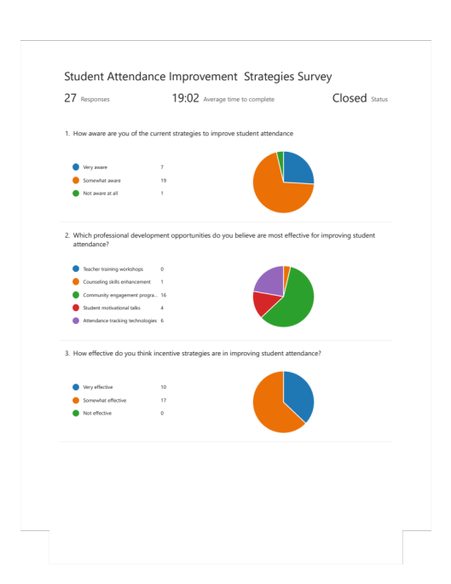
https://forms.office.com/r/kPGgsBRn5J?origin=lprLink

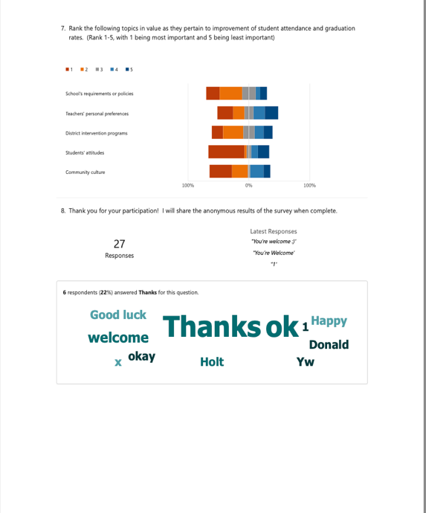
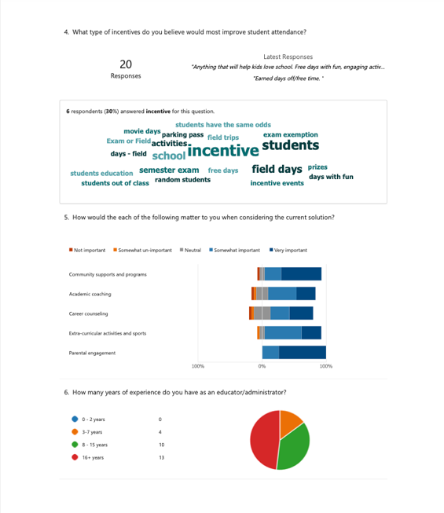

- WVDE Policy 2425-
Community Schools: Promoting Health, Safety, Well-Being and Academic Success of Students

https://apps.sos.wv.gov/adlaw/csr/readfile.aspx?DocId=25989&Format=PDF

This policy sets forth the state guidance for the develop of safe and effective public schools.

- WVDE Policy 2340- West Virginia Measures of Academic Progress

https://apps.sos.wv.gov/adlaw/csr/readfile.aspx?DocId=55355&Format=PDF
This policy helps determine and regulate the means of establishing academic progress through testing.

- Raleigh County Schools
Student Attendance Brochure

https://core-docs.s3.us-east-1.amazonaws.com/documents/asset/uploaded_file/1847867/Attendance_Brochure_23-24.pdf
This policy describes the regulations of attendance for Raleigh County Schools.

- West Virginia, Department of Education
Zoom WV
https://zoomwv.k12.wv.us/Dashboard/dashboard/2174

This site is part of the data collection information for the West Virginia Department of Education. Attendance and graduation rate information for all counties, schools, and state can be organized and gathered here.

(b) Sustainability
- Identify in 1-2 paragraph(s) how your accountability project informs strategic and tactical challenges to the school’s systems.

As found within my Accountability project, many challenges exist regarding improving attendance and the graduation rate. Among the challenges most noted, was community culture and parental attitude towards student attendance. By finding ways to educate and include parents and families about incentives and data representing student success, our school will be better able to influence deciding factors to help avoid truancy issues.

- Provide a 1-2 paragraph(s) narrative detailing how your accountability project promotes continuous and sustainable school improvement.

Our attendance team and school administration now have data prepared for review and analysis that can help with ongoing results. as result of this school-based study, our county can utilize some of the same policies that are being developed as a result at our school level as results prove favorably over time. Analysis of on-going data results will prove useful and provide a clear representation of current information and will allow for identification of needed change when necessary.

Part 5.b.2_ Measures of Academic Progress attachment.
WVDE Policy 2340- West Virginia Measures of Academic Progress
https://apps.sos.wv.gov/adlaw/csr/readfile.aspx?DocId=55355&Format=PDF

- In a table, show a multiple-year (year 1, year 2, year 3) resourcing plan aligned with your school’s vision, mission, and improvement processes listing what is needed for assessing and maintaining the necessary resources for the sustainability of your project.

Year 1 | Year 2 | Year 3
For year 1, all data reported at the school, district, and state level will be collected and analyzed by the school leadership and attendance teams. No funding needing for this initial review of data. | For year 2, school finance can be utilized to provide local incentives for students maintaining good attendance records. The recommendations of the attendance team will determine the number and types of incentives made available for the students. | Following the review of local school data, county and district funding can be allocated for using to incentivize programs for improved attendance and graduation programs. Truancy diversion/Dropout prevention programs are supported by county levy money and will look to gain support county-wide.

PART 6: Communication of Results and Outcomes: In collaboration with the onsite mentor, school leadership, and faculty members, interns demonstrate the capacity to communicate through oral, written, and digital means with the larger organizational, community, and political context when advocating for the needs of their school and community (NELP 5.3).

  - Considering your multi-year resource plan, in 1-2 paragraph(s) discuss your resource plan in relation to the district and policy context of your internship site.

For year one, all data reported at the school, district, and state level will be collected and analyzed by the school leadership and attendance teams. No funding needing for this initial review of data. For year two, school finance can be utilized to provide local incentives for students maintaining good attendance records. The recommendations of the attendance team will determine the number and types of incentives made available for the students. Following the review of local school data, county and district funding can be allocated for using to incentivize programs for improved attendance and graduation programs. Truancy diversion/Dropout prevention programs are supported by county levy money and will look to gain support county-wide. Over the course of three years, I would like to see the process grow and become successful at the school, district, and county levels and improve attendance data and graduation rates.

  - Considering your communication strategies, discuss in 1-2 paragraph(s) how you advocated for the needs of your school and your community during the implementation and execution of your accountability project.

While preparing for the Accountability protocol project, I was able to sit down with our County Attendance Director, Kim Lacy, and discuss the need for revisions to the attendance policies. She explained the various incentive programs throughout the county at the elementary, middle, and high school levels. In the years following COVID-19, there have been many obstacles to overcome in terms of attendance and graduation rates. The county I work in has been successful, but not without challenges.

Next, I was able to visit with our Assistant Superintendent of Schools, Eric Dillon. I was able to gain some valuable insight from his position and see the bigger picture of attendance as a district and county. At a local level, I was able to speak with our principal and the two principals who served in our school prior to now. I was also able to meet with principals of local elementary schools, middle schools, and from other counties to discuss these matters. I met with our school attendance team and local school leadership teams as well at various times throughout the semester. Each discussion led to an exchange of ideas for my program, as well as our school policies.

  - Provide a table with 2 columns that list the types of communication used in the left column (e.g., oral, email, workshops, meetings, website, newsletter, etc.) and the audience in the right column (e.g., parents, students, teachers, district office, administration, community) for each communication. Attach evidence, such as a link, a transcript, an email, a script, etc., for each type of communication listed on the table. (Test any internet links to ensure that they are functioning.)

January 24- Oral discussion, departmental meetings | 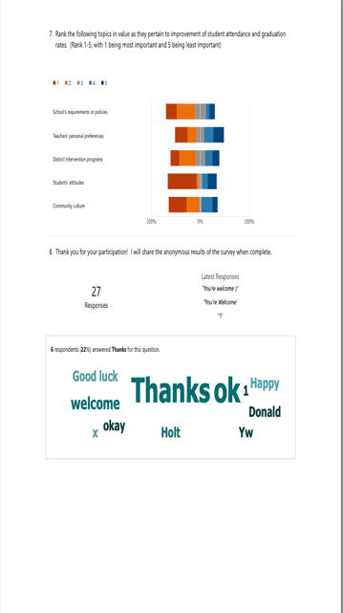  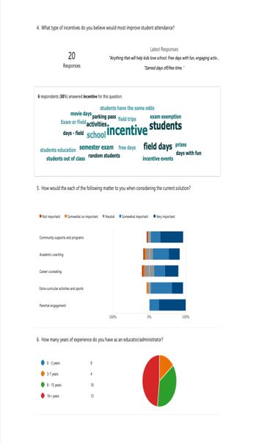  Data Collection Interviews
February 14- Principal’s Meeting with County Superintendent and Staff | 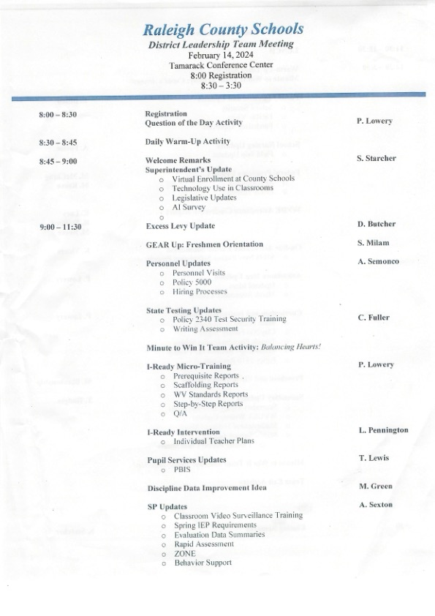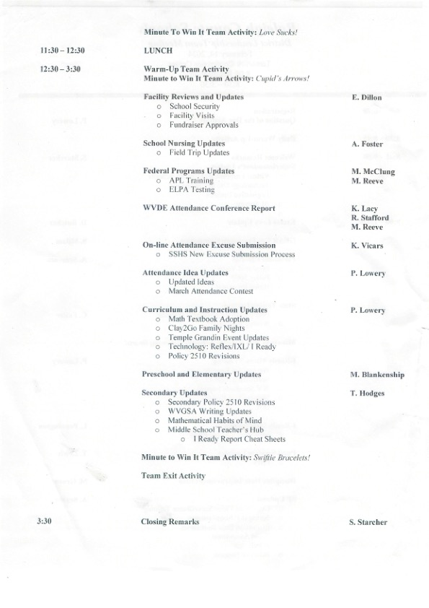
March 29- School Leadership and Attendance Team Meeting | 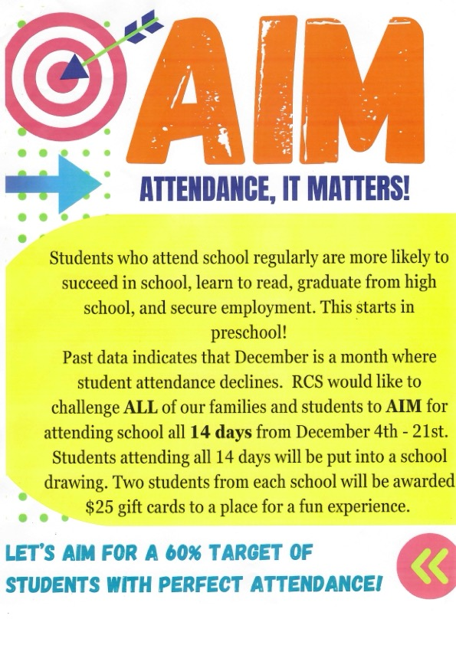  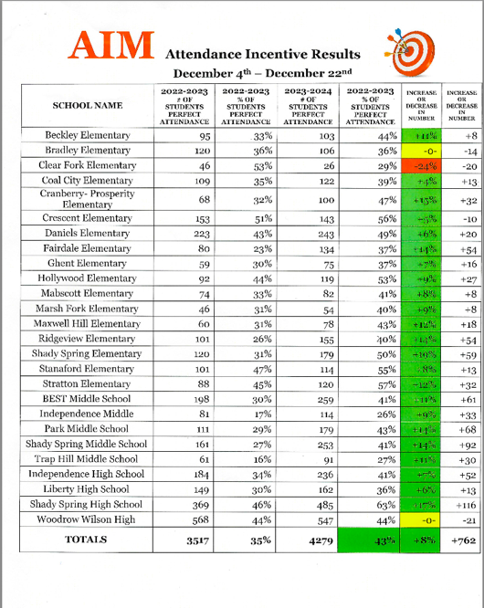
April 12- Faculty Senate Group Meeting | 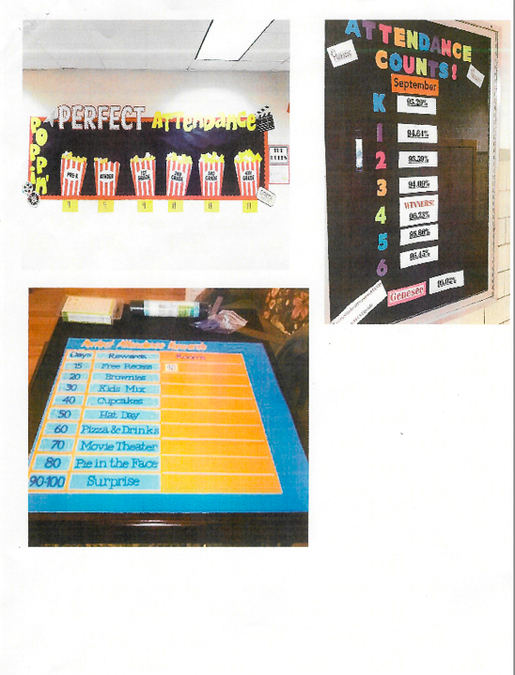  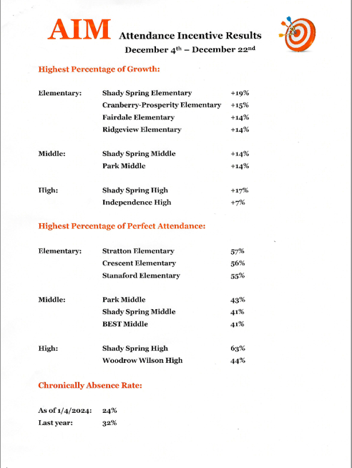  On-site, departmentalized meeting.

- Discuss in 1-2 paragraph(s) how the items on your communications table informed the larger organizational, community, and political contexts when advocating for the needs of the school community.

Each of the above-listed events were a gathering of educational stakeholders to brainstorm processes to improve school, district, and county issues. At each opportunity, discussion was encouraged to formulate a plan for improvement at each level. All parts included teachers, administrators, board members, and community members with interests in improving and celebrating school and student successes. The discussion of this project led to ideas of how to better serve our students, how to include community supports, and how to provide the means of funding the program as an on-going process for the freshman cohort and beyond.

Attachments and Links:
WVDE Policy 4110- Attendance
https://apps.sos.wv.gov/adlaw/csr/readfile.aspx?DocId=53931&Format=PDF
WVDE Policy 2425- Community Schools: Promoting Health, Safety, Well-Being and Academic Success of Students
https://apps.sos.wv.gov/adlaw/csr/readfile.aspx?DocId=25989&Format=PDF

WVDE Policy 2340- West Virginia Measures of Academic Progress
https://apps.sos.wv.gov/adlaw/csr/readfile.aspx?DocId=55355&Format=PDF

WVDE Policy 4200- Provision of Equal Opportunity in West Virginia Public Schoolshttps://apps.sos.wv.gov/adlaw/csr/readfile.aspx?DocId=6275&Format=PDF

WVDE Policy 4373- Expected Behavior in Safe and Supportive Schools

https://apps.sos.wv.gov/adlaw/csr/readfile.aspx?DocId=51038&Format=PDF

Raleigh County Schools
Student Attendance Brochure
https://core-docs.s3.us-east-1.amazonaws.com/documents/asset/uploaded_file/1847867/Attendance_Brochure_23-24.pdf

Raleigh County Schools Chronic Illness Form
https://core-docs.s3.amazonaws.com/documents/asset/uploaded_file/1847869/22-23_CHRONIC_ILLNESS_FORM.pdf

Raleigh County Schools Student Residency Brochure
https://core-docs.s3.amazonaws.com/documents/asset/uploaded_file/1847889/21_22_Residency_Bbrochure.pdf

Raleigh County Schools Graduation Requirements
https://core-docs.s3.amazonaws.com/documents/asset/uploaded_file/1868837/Graduation_Requirements.pdf

West Virginia, Department of Education Zoom WV
https://zoomwv.k12.wv.us/Dashboard/dashboard/2174

Teacher Survey Responses
https://forms.office.com/Pages/DesignPageV2.aspx?prevorigin=shell&origin=NeoPortalPage&subpage=design&id=S7AZ4AwzekaLrgn7FzdNava3BC43LMJIttd8mEw-bKxUMEVQMjdHS0VCMk1MREQ2SDRTMTRGME43Vi4u&analysis=true

Qualitative Educator Interviews
https://wvk12my.sharepoint.com/:w:/r/personal/dwbarnet_k12_wv_us/Documents/Attachments/Qualitative%20Data%20Collection%20Interview%201.docx?d=w1656f4fba9b7487fa69b5ccaddadba7a&csf=1&web=1&e=3onyaM

Attendance- March Madness Incentive


